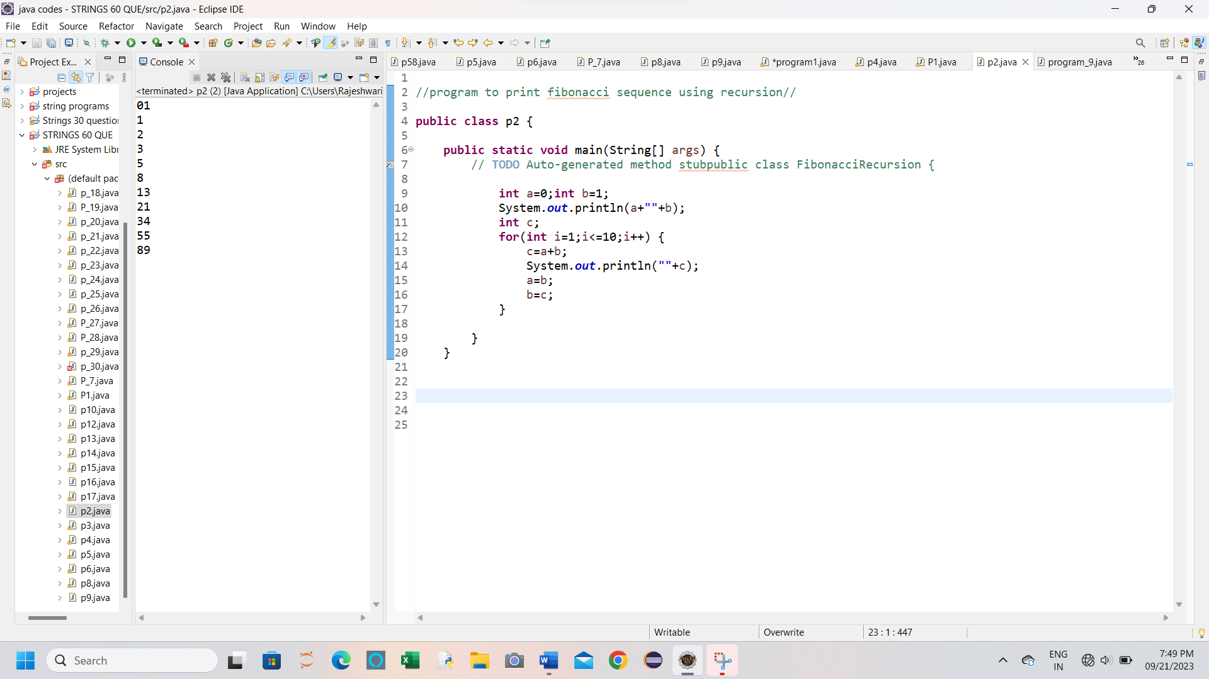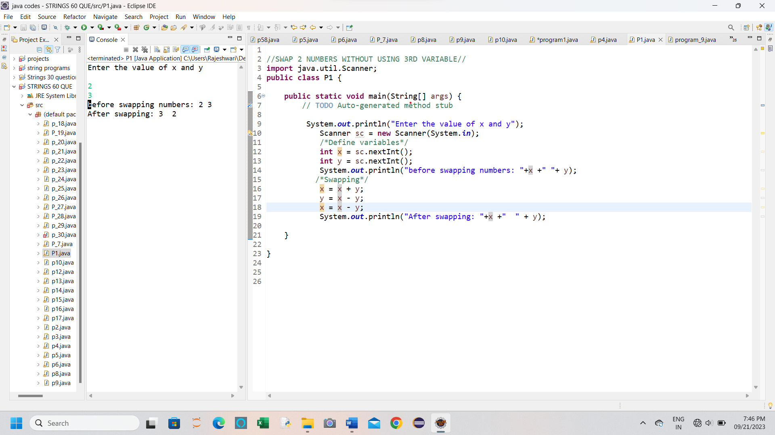

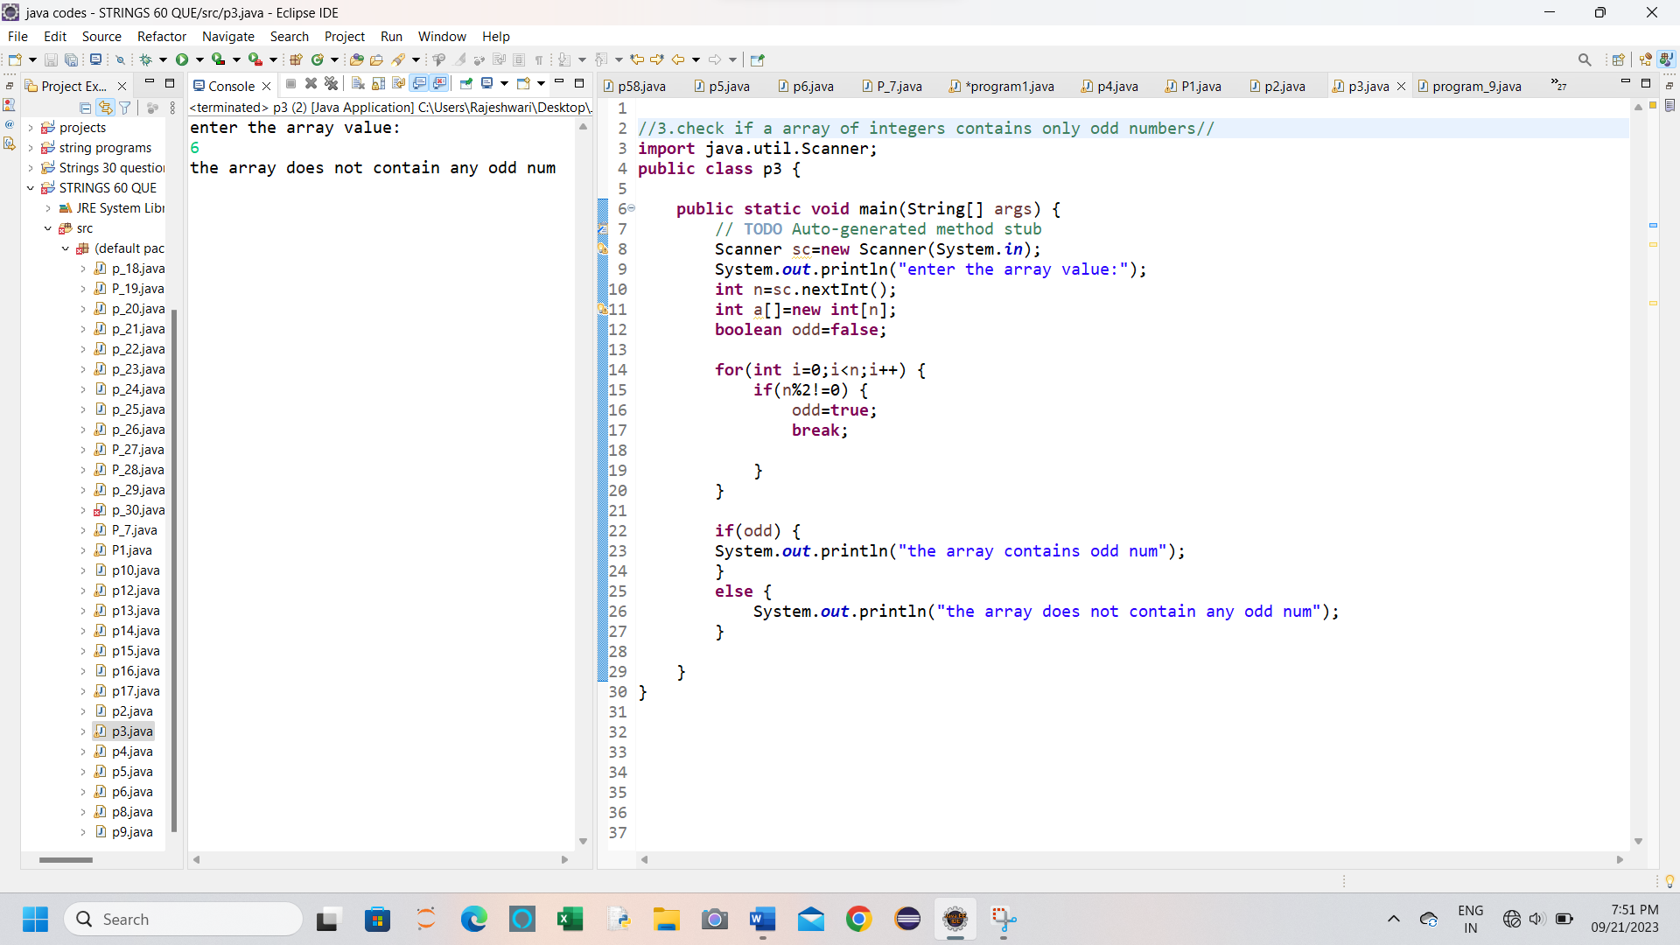

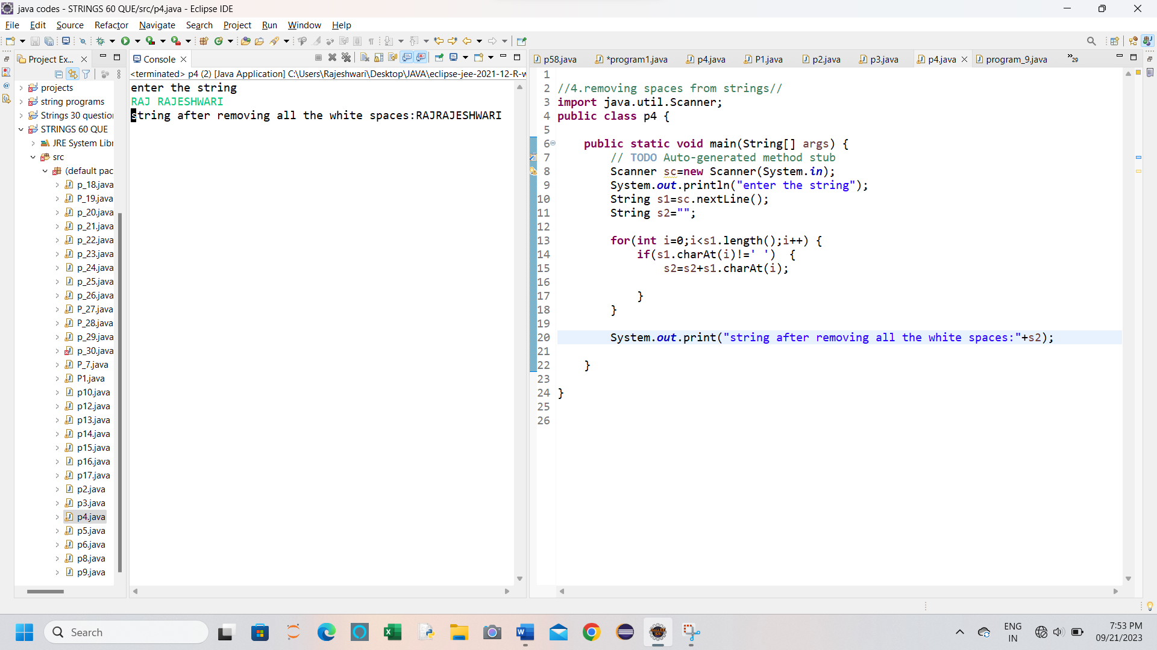

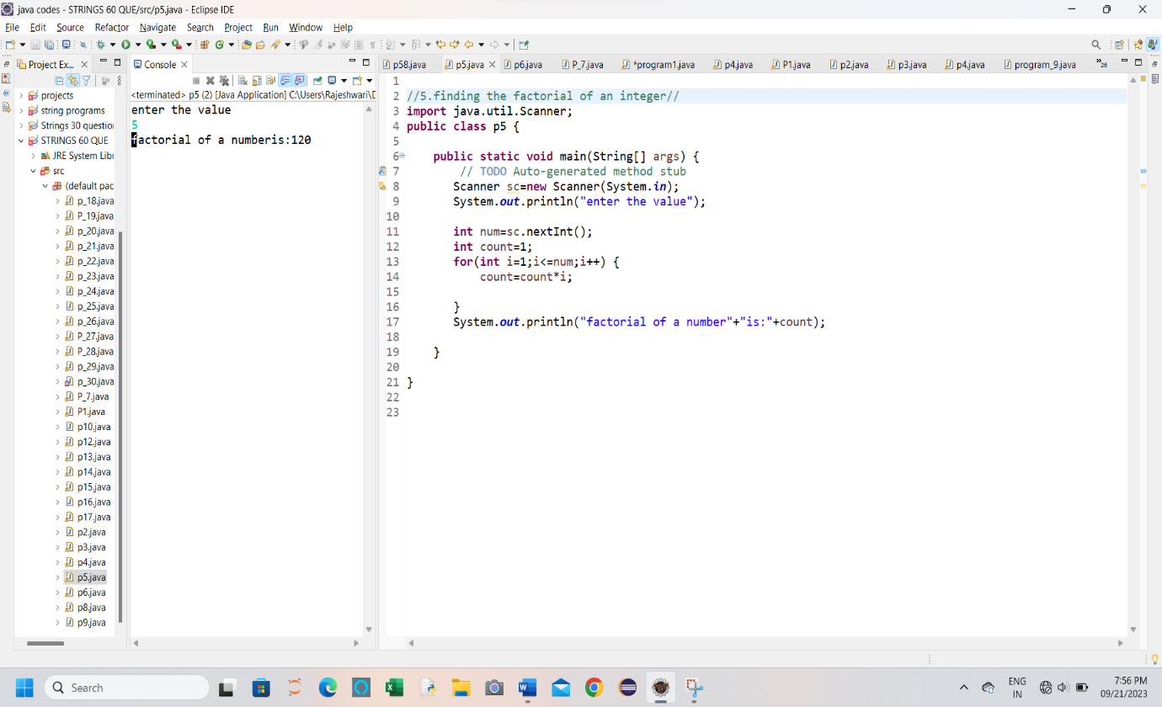

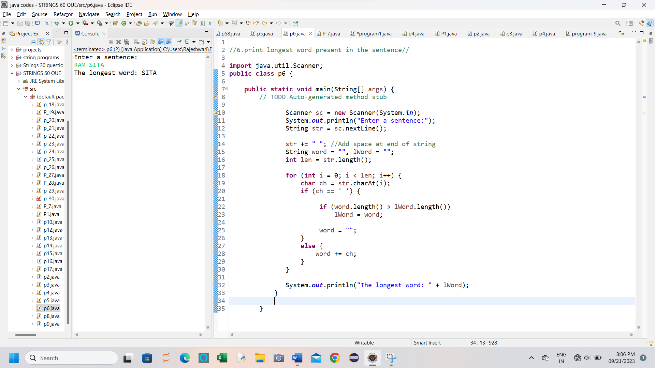

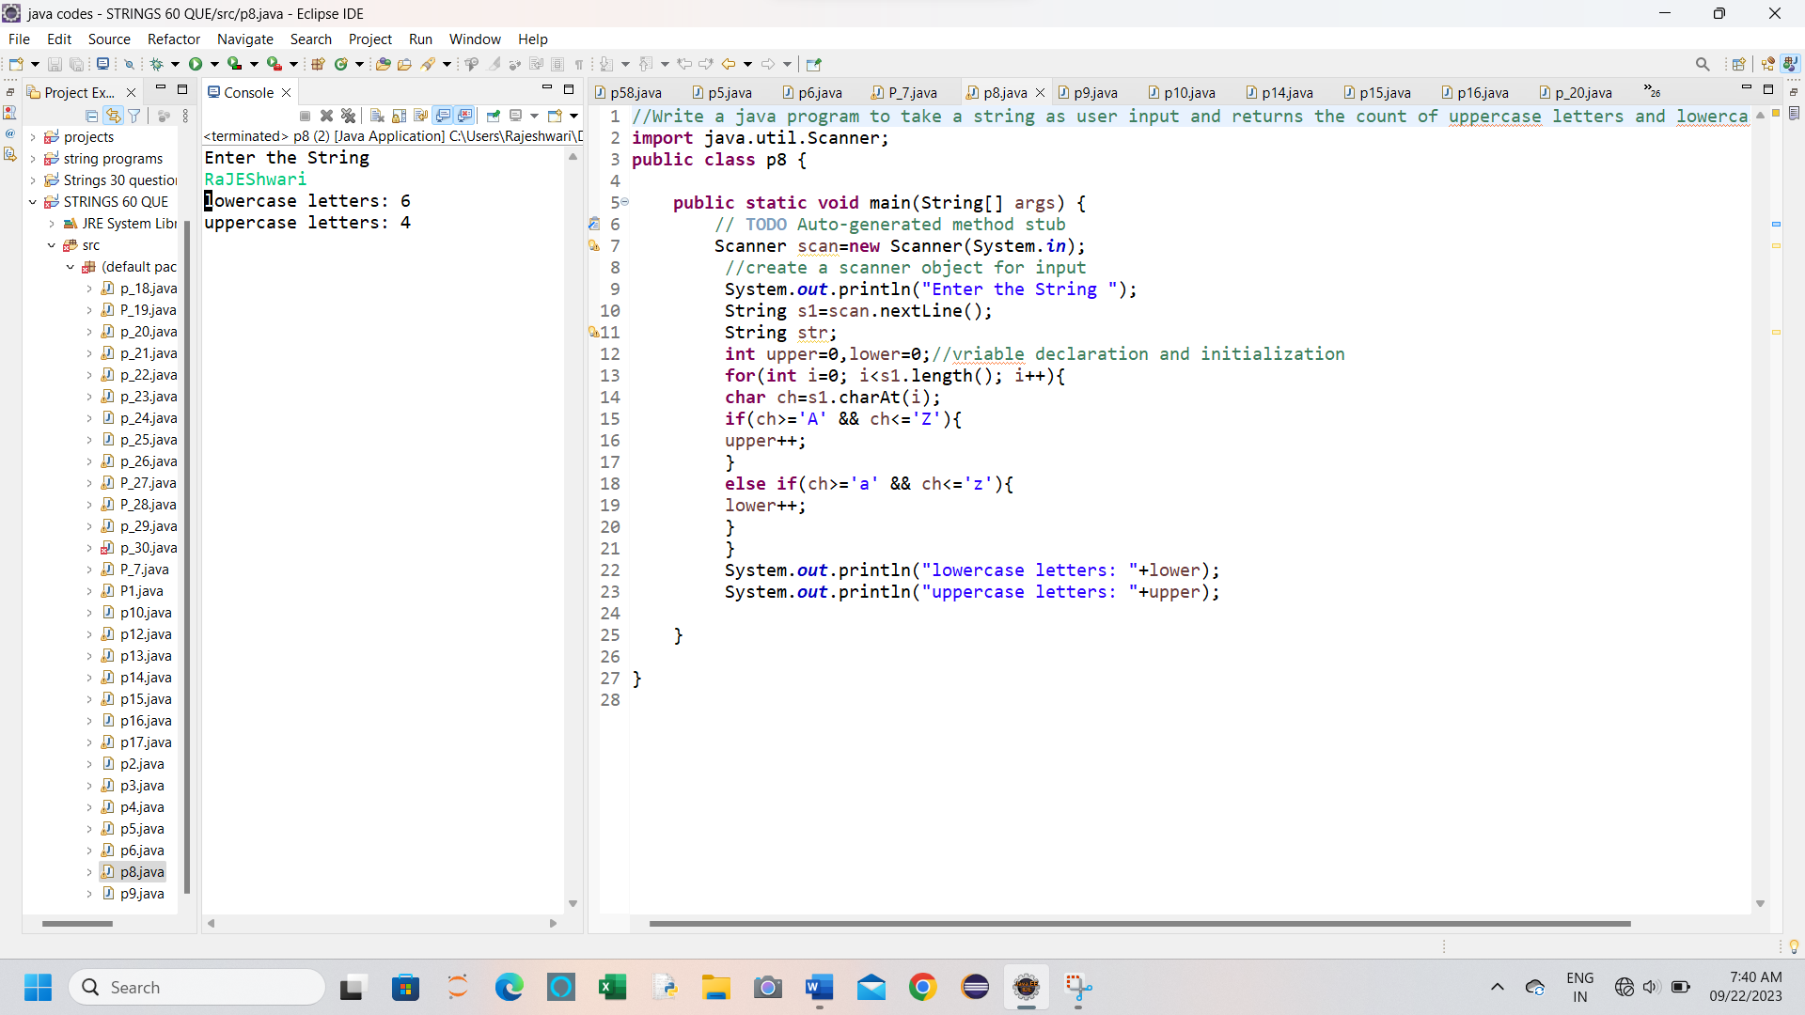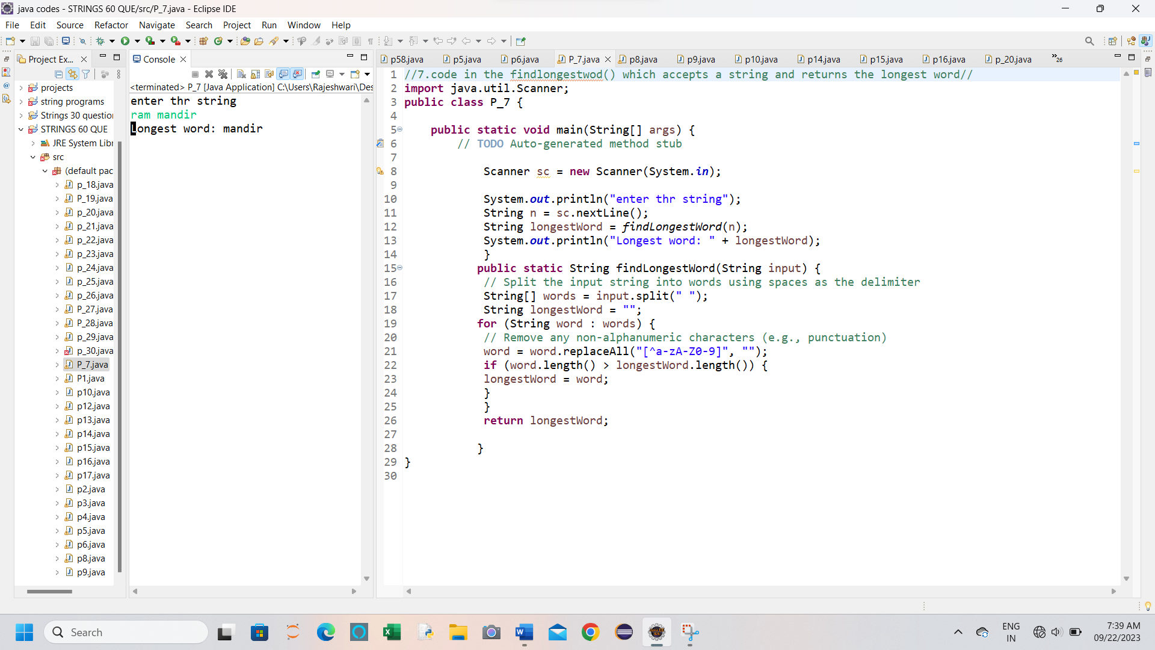

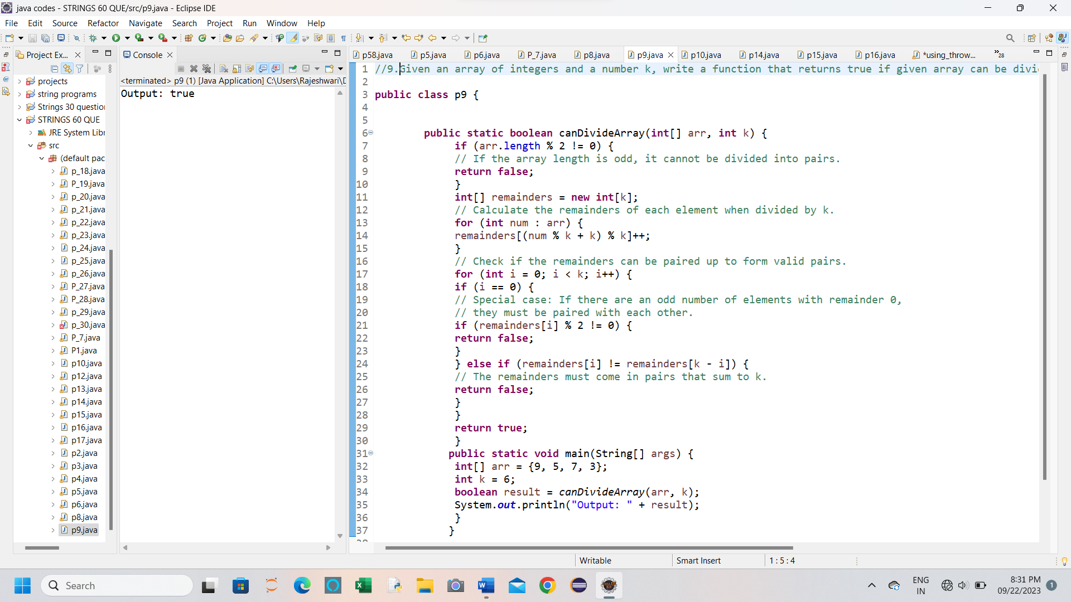

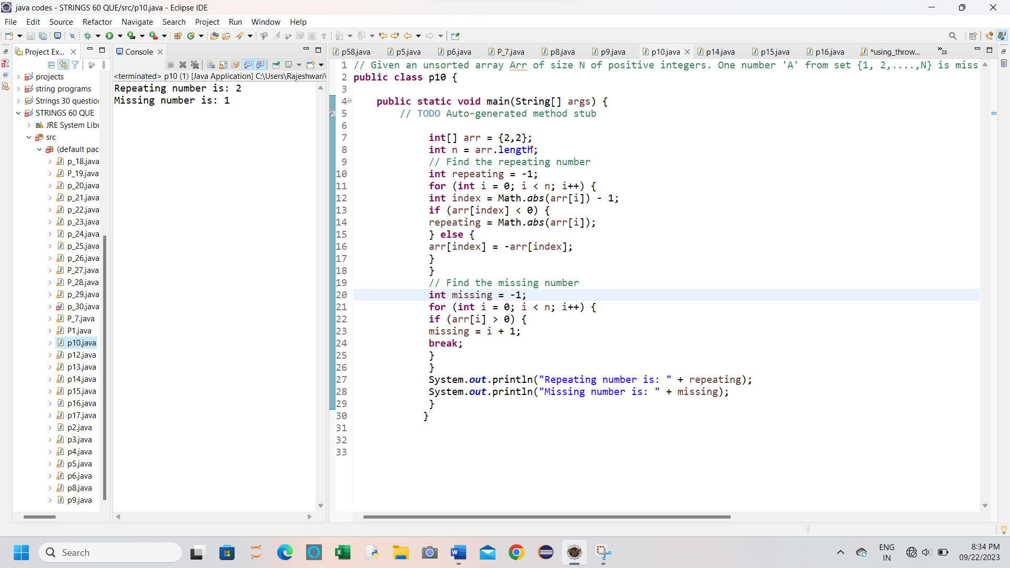

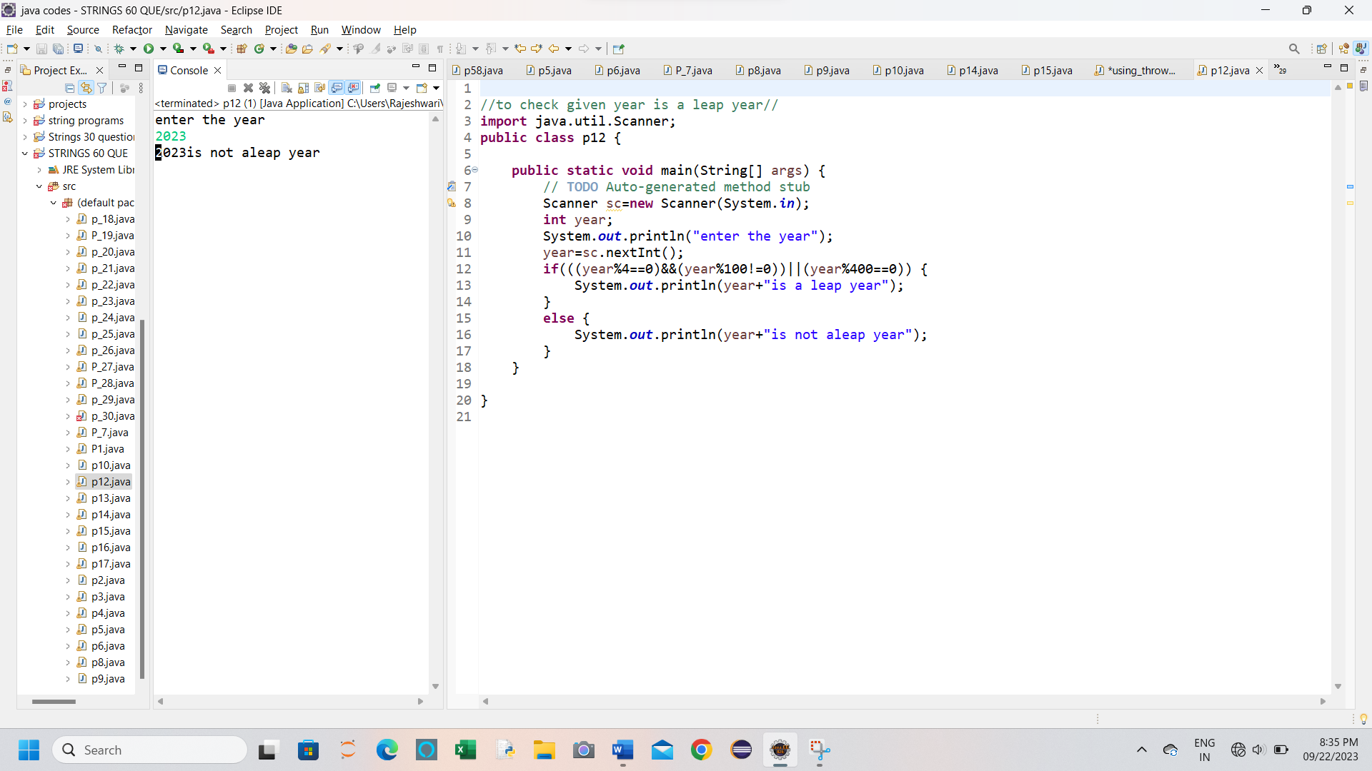

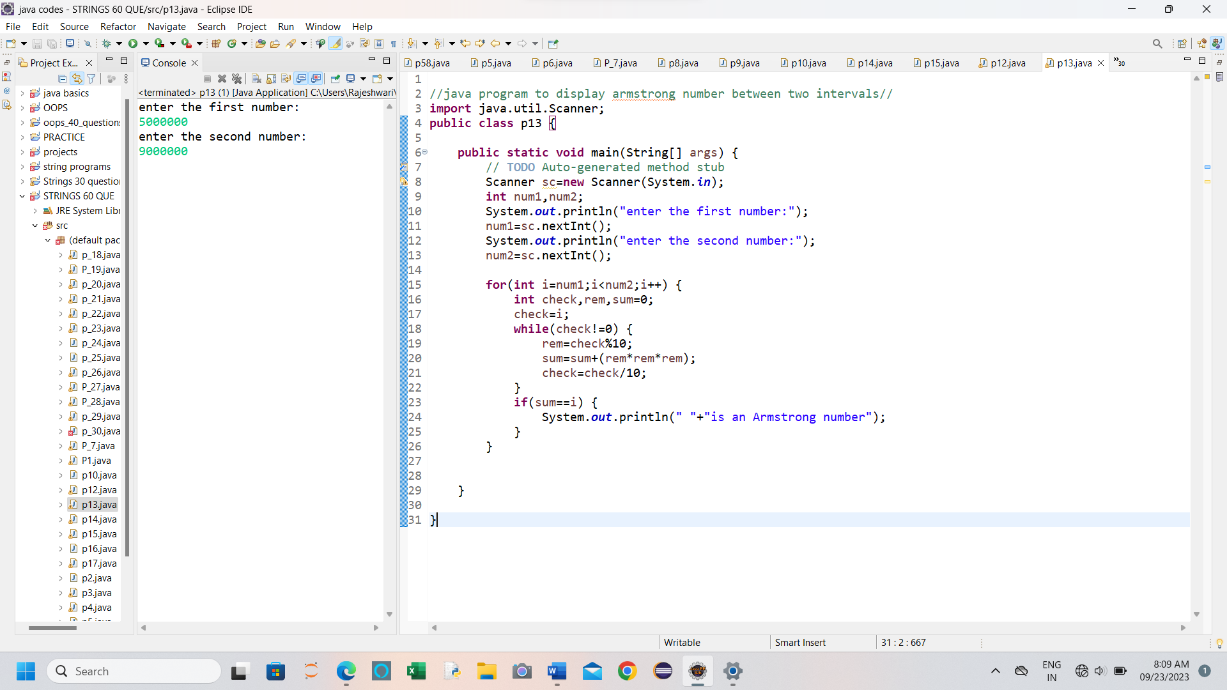

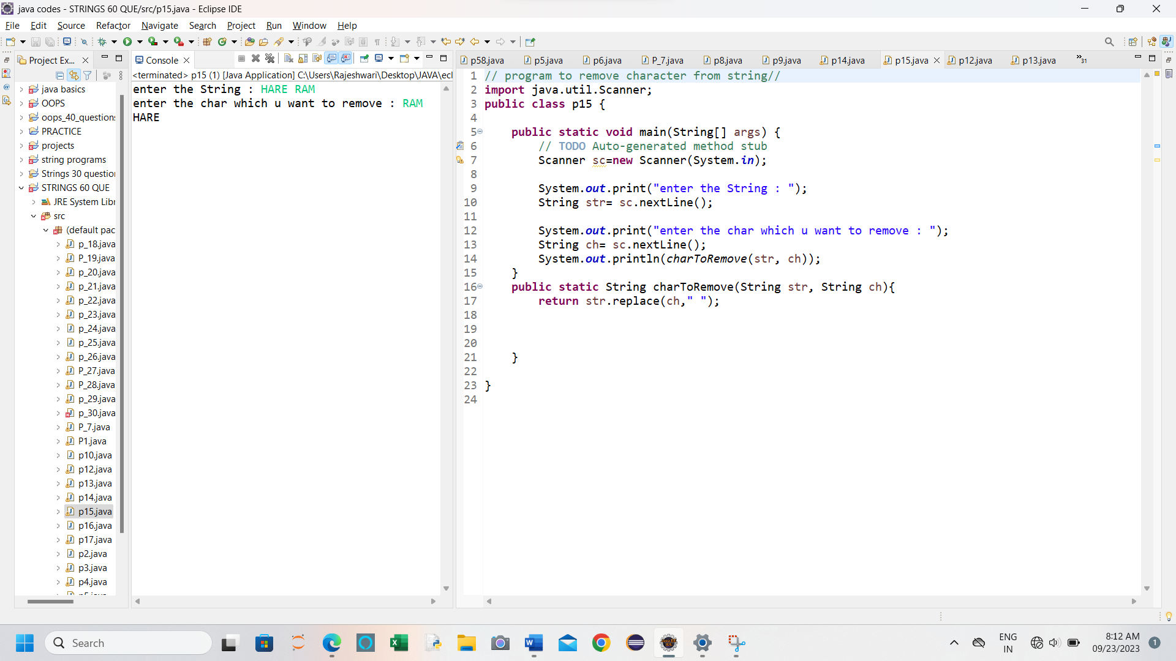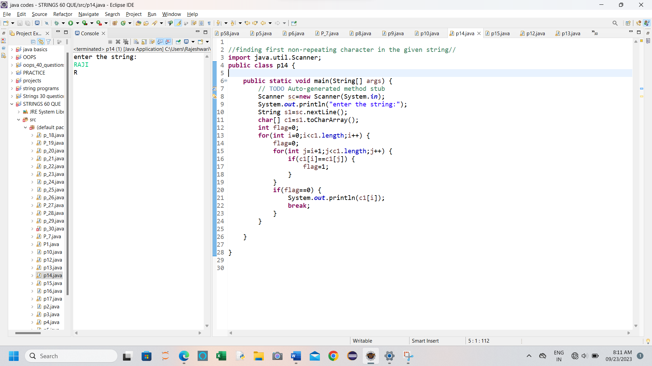

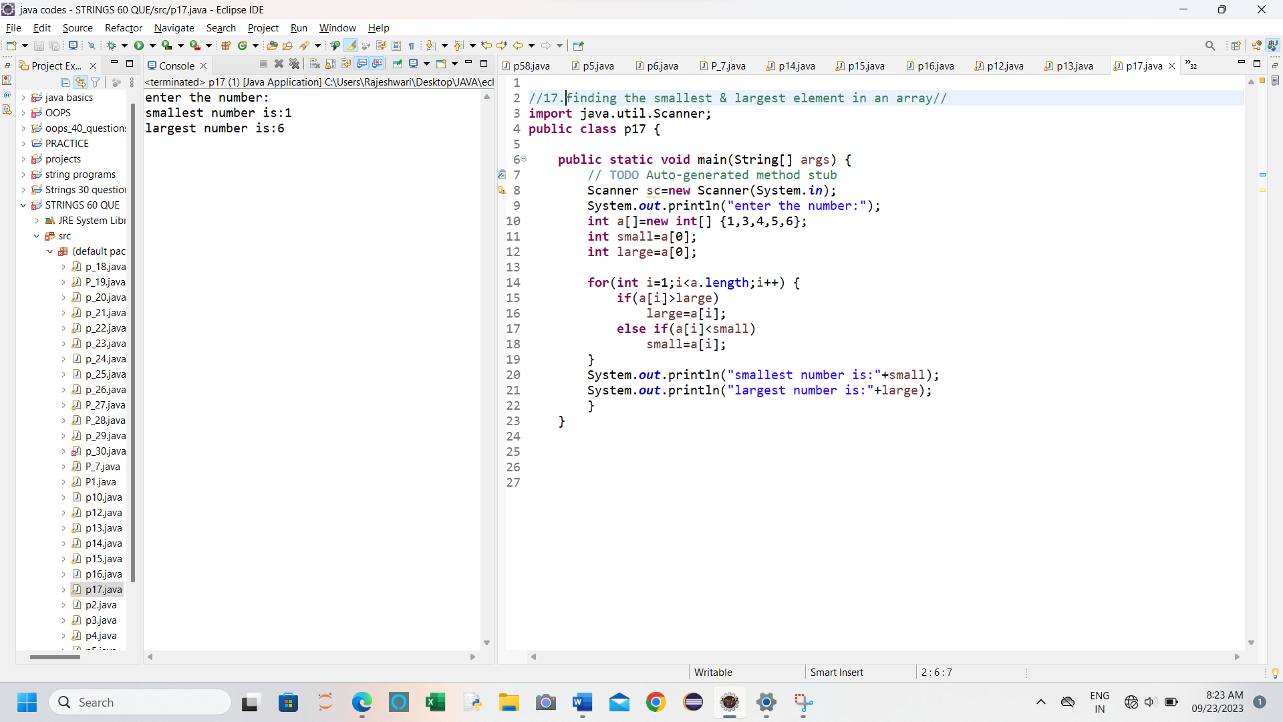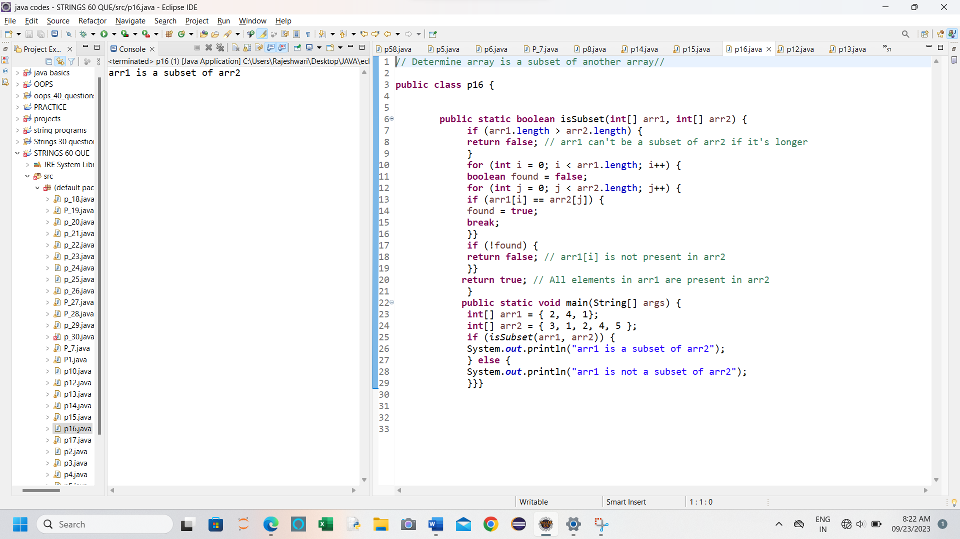

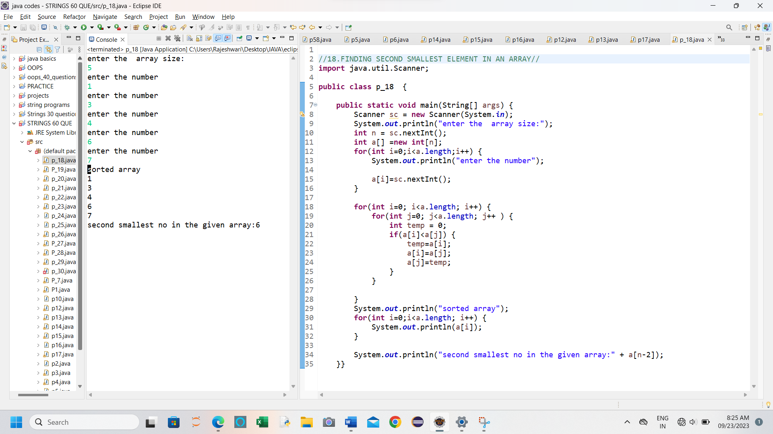

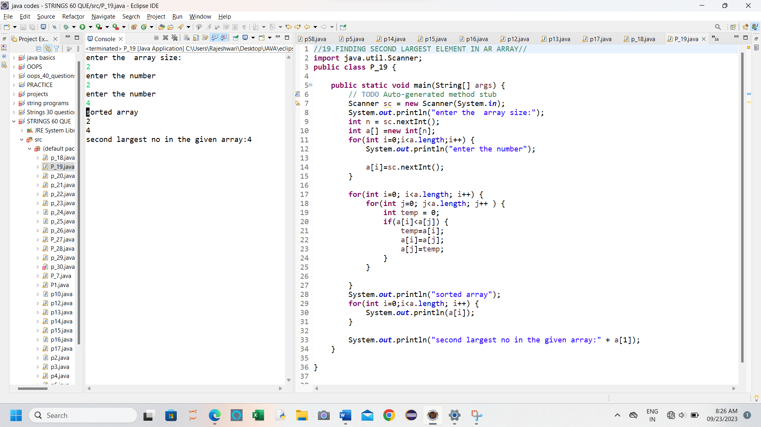

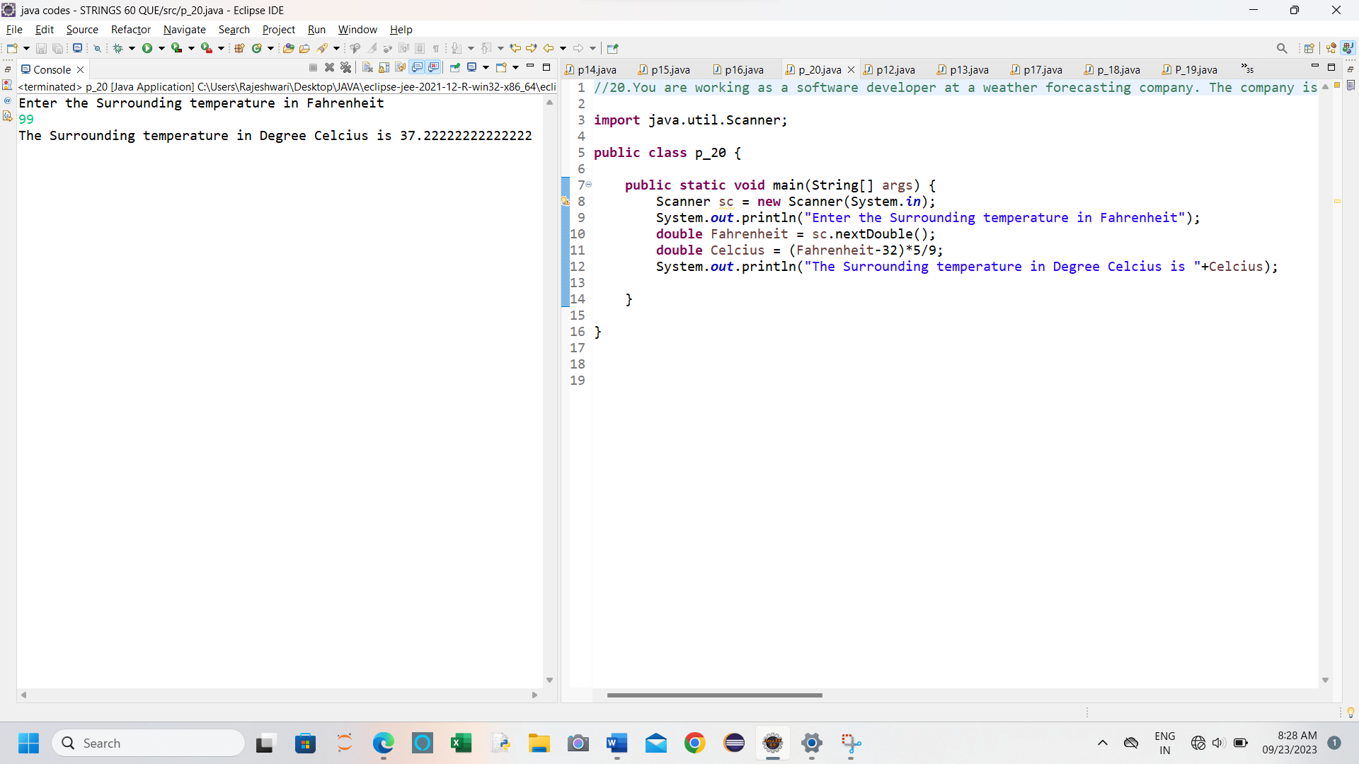

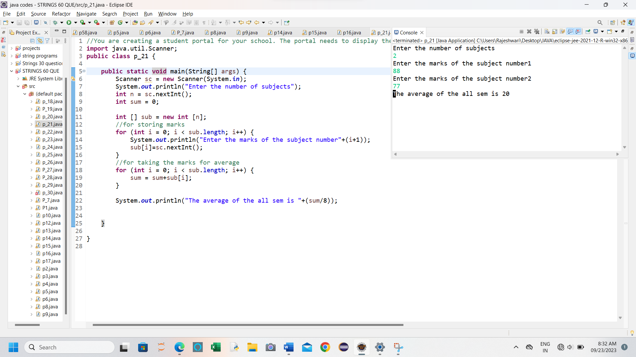

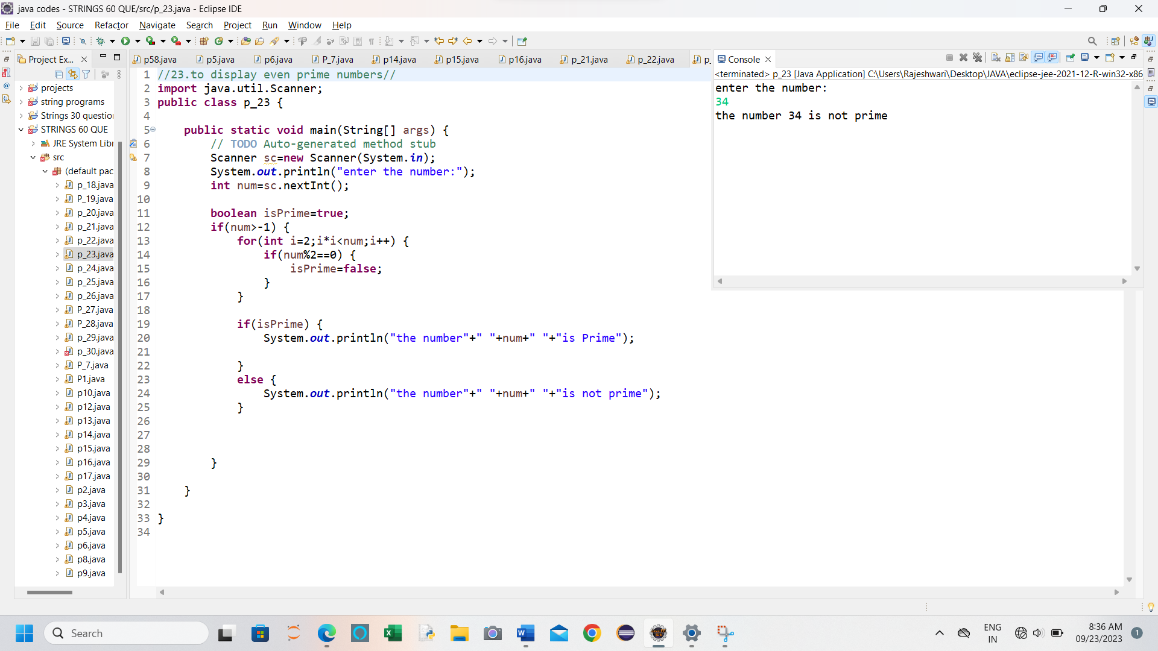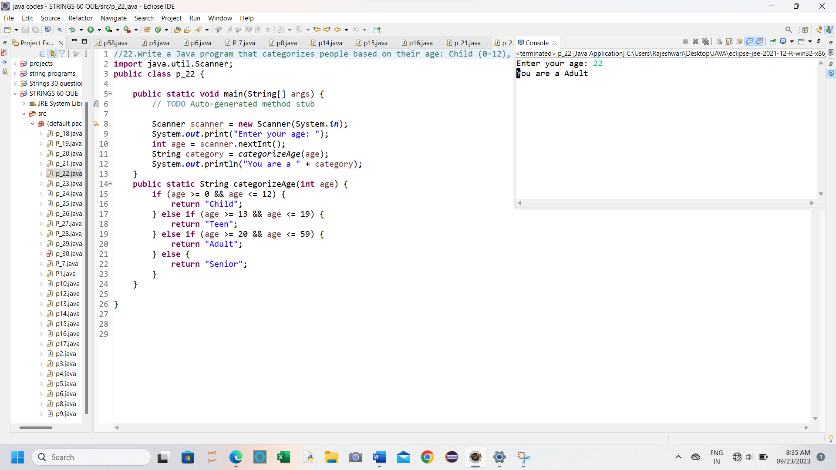

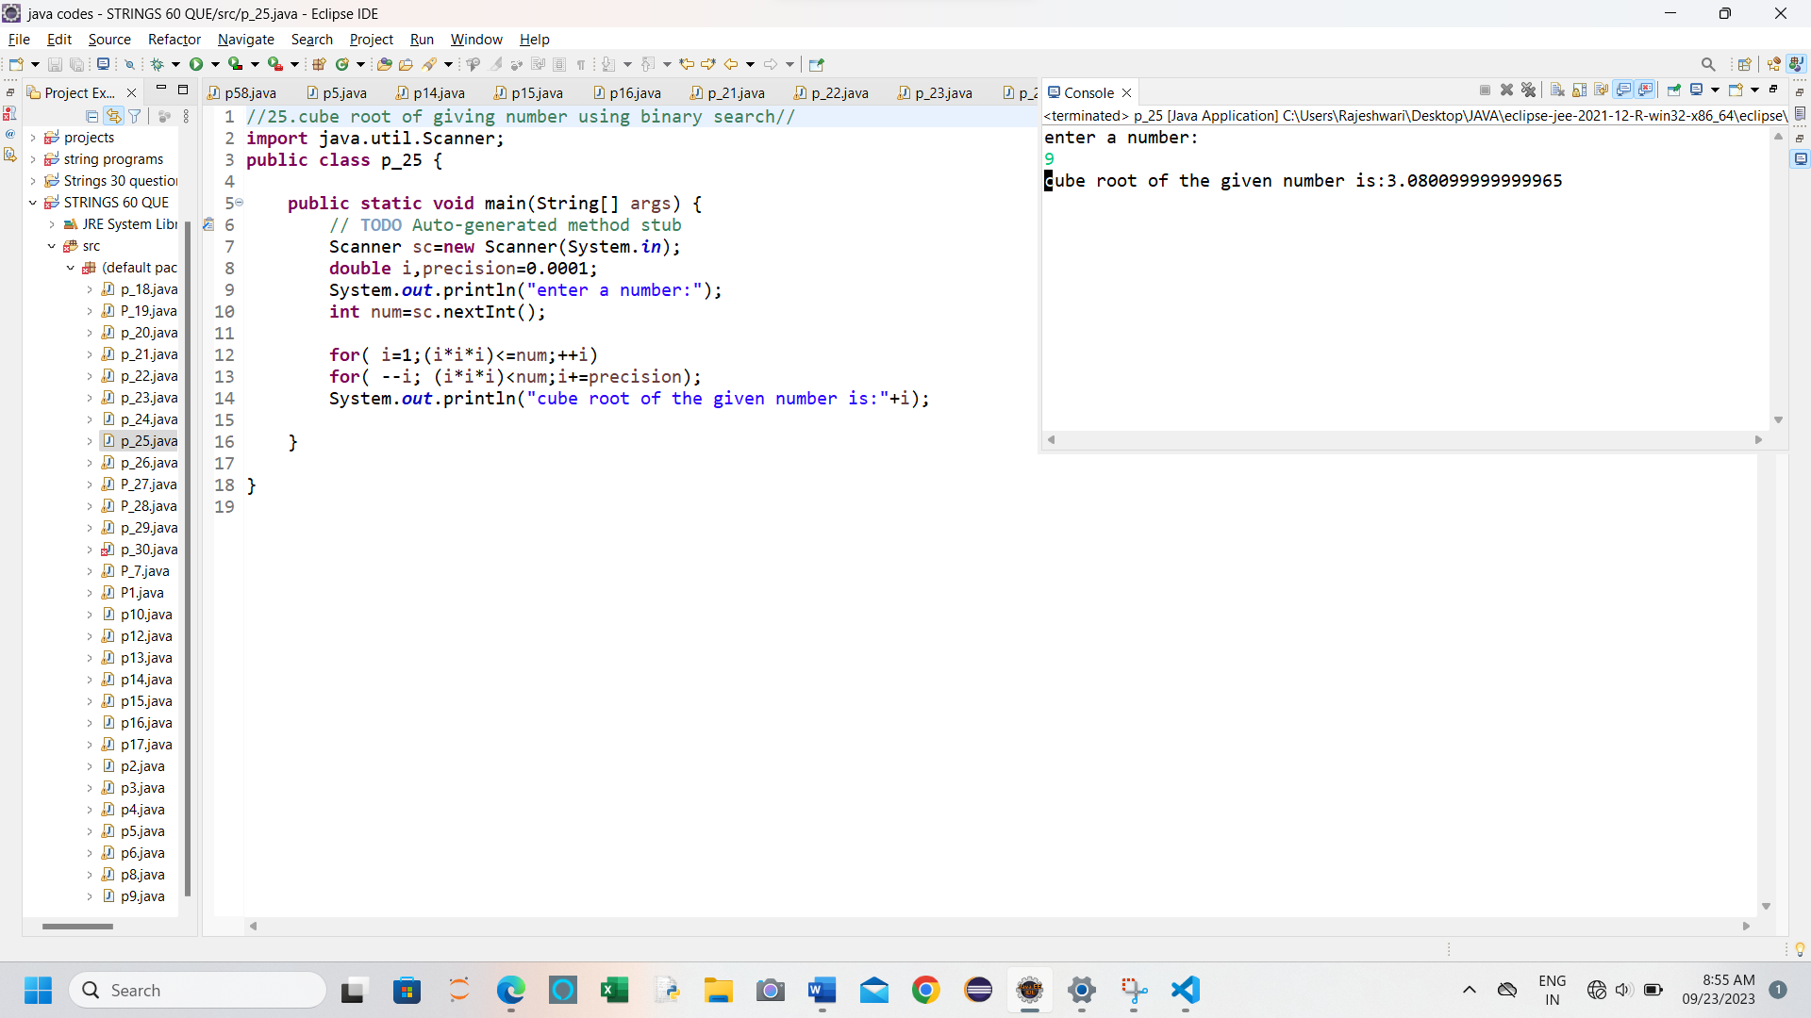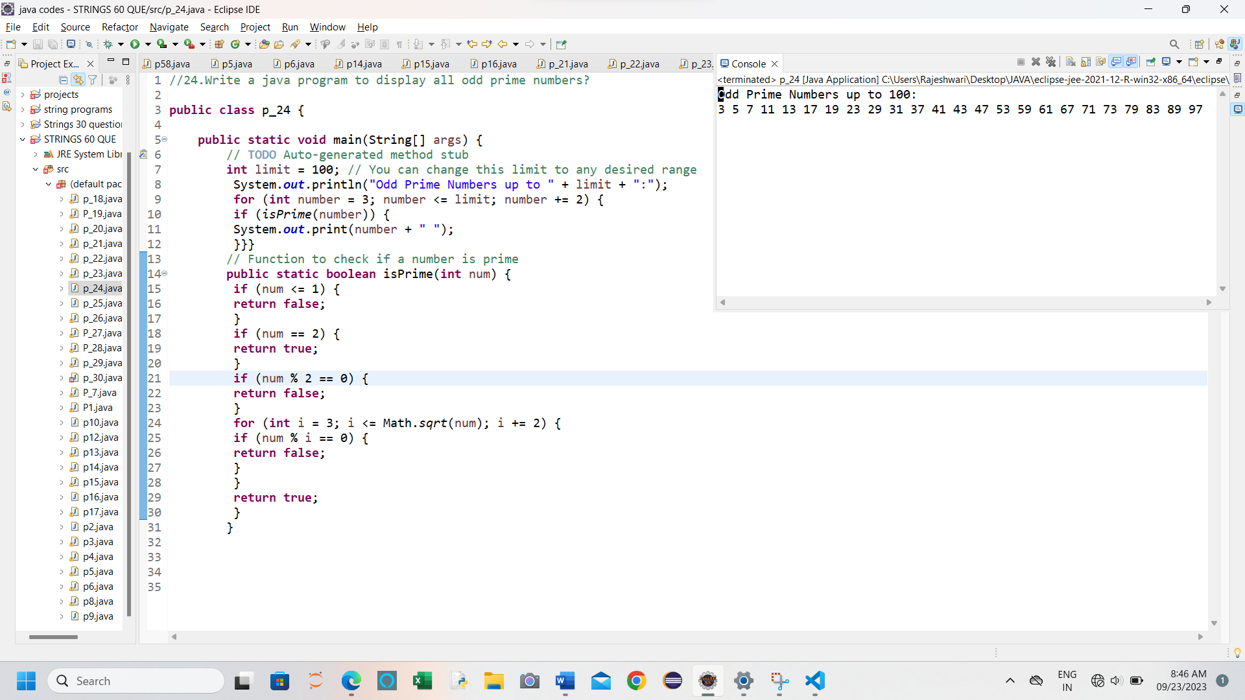

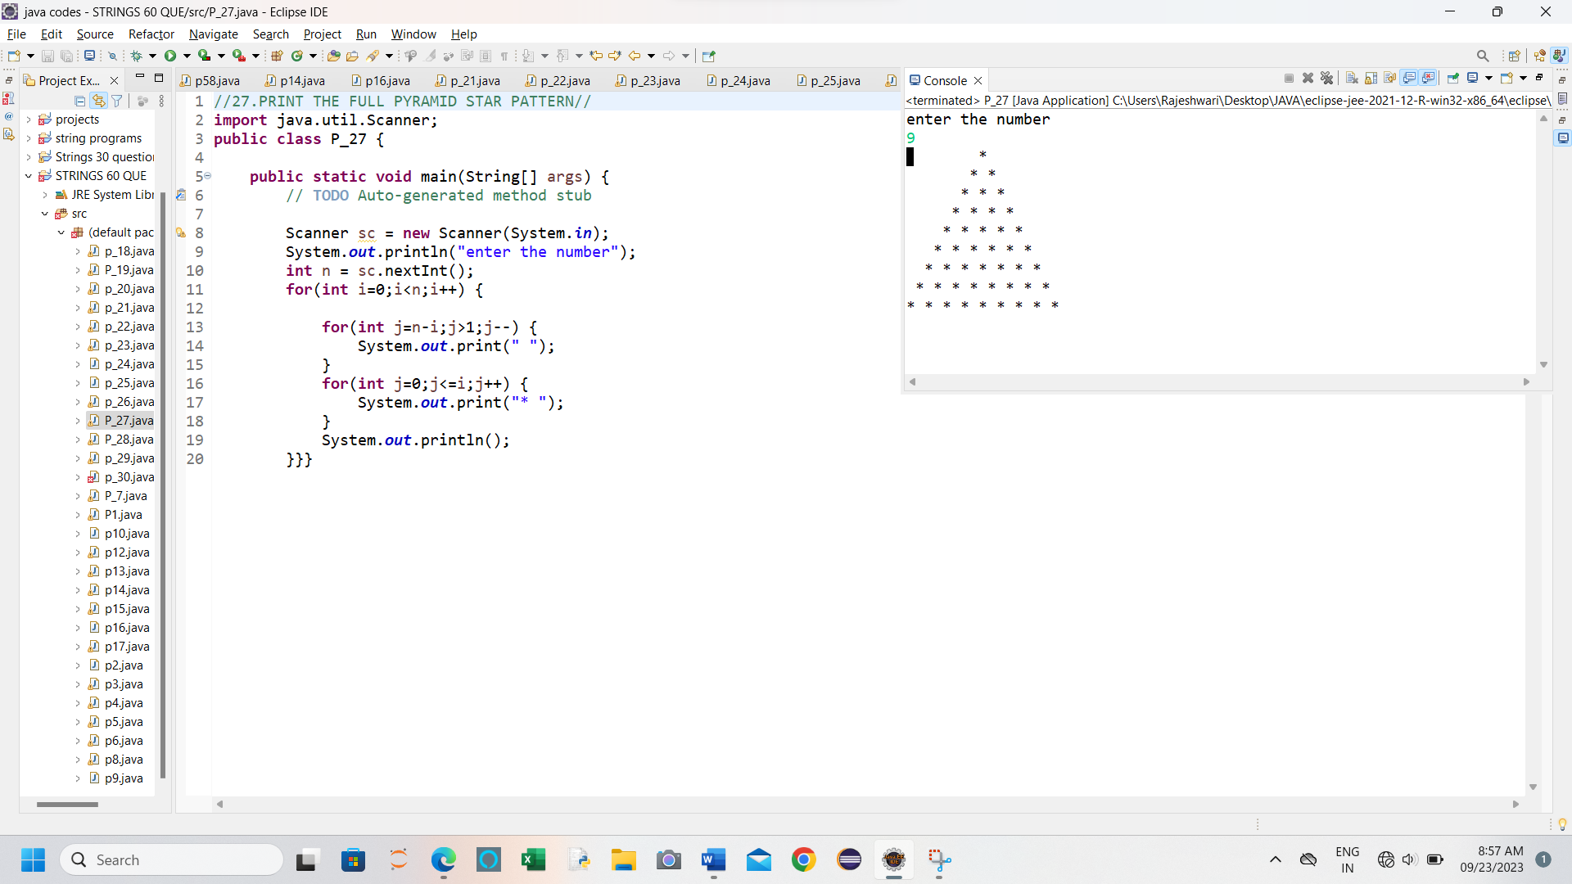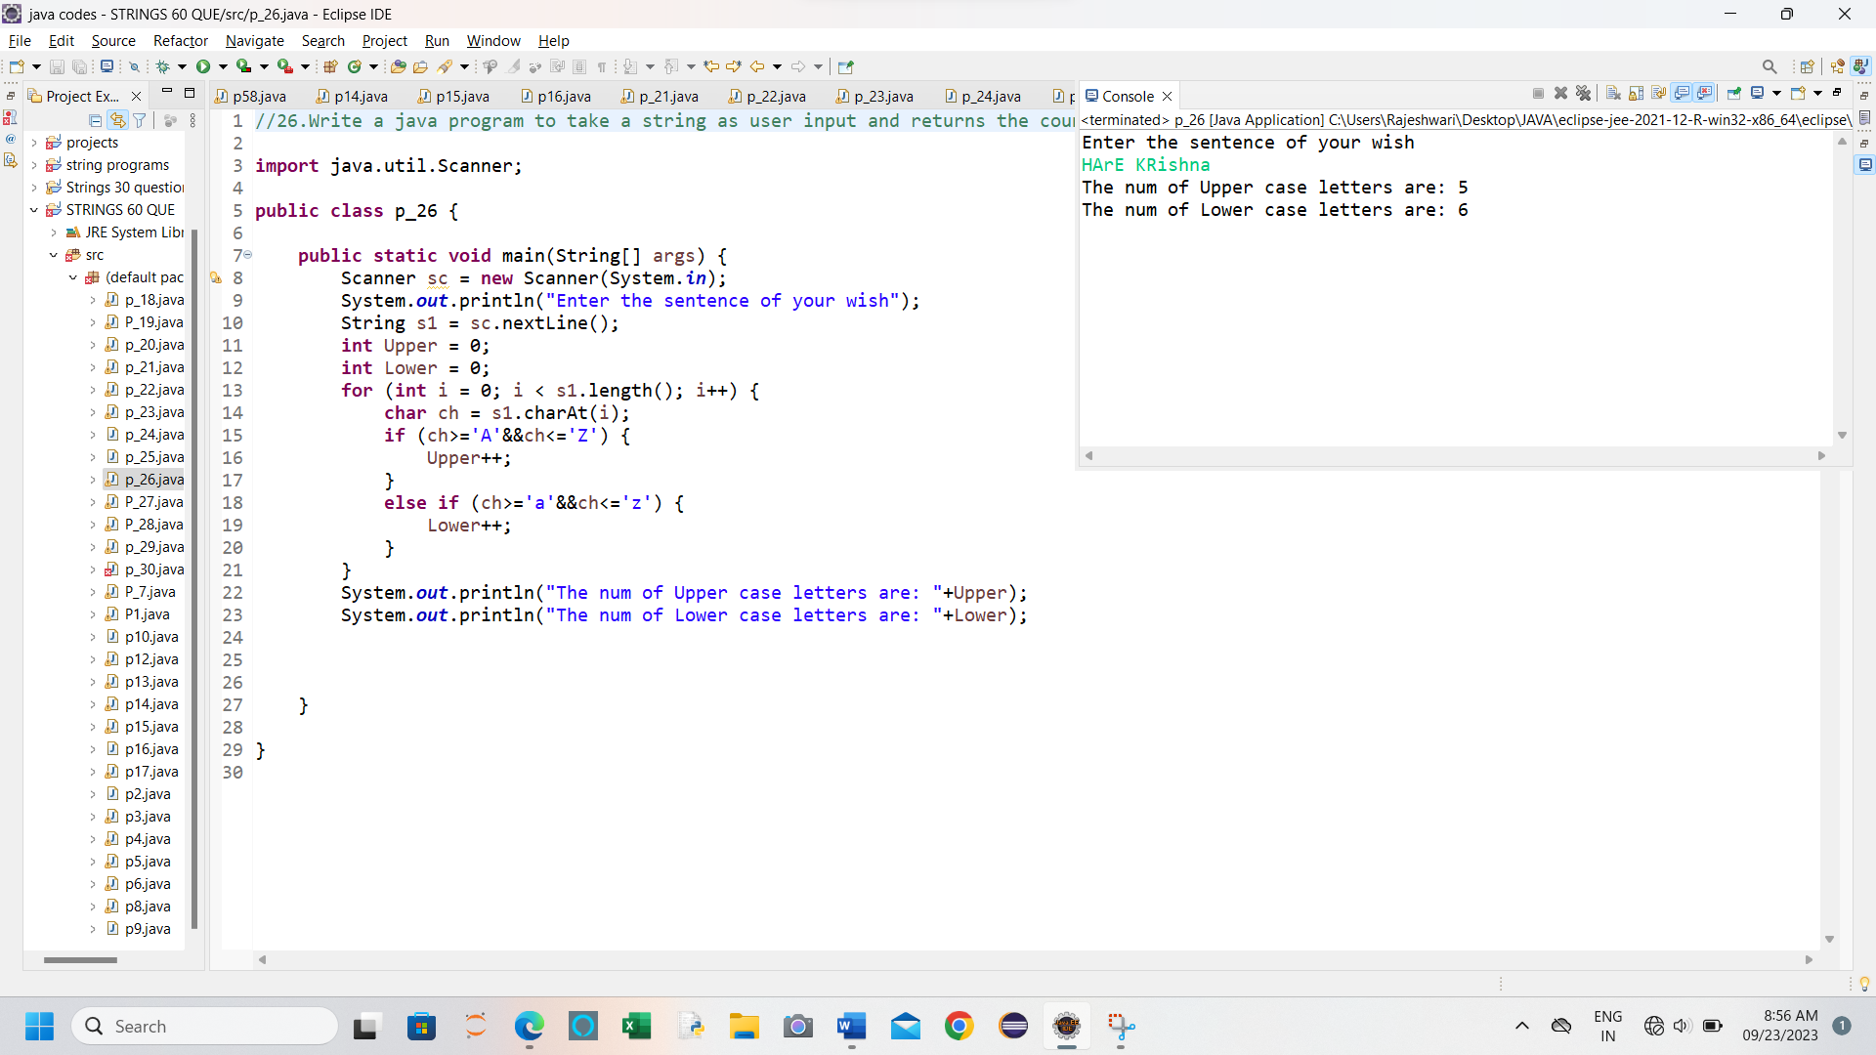

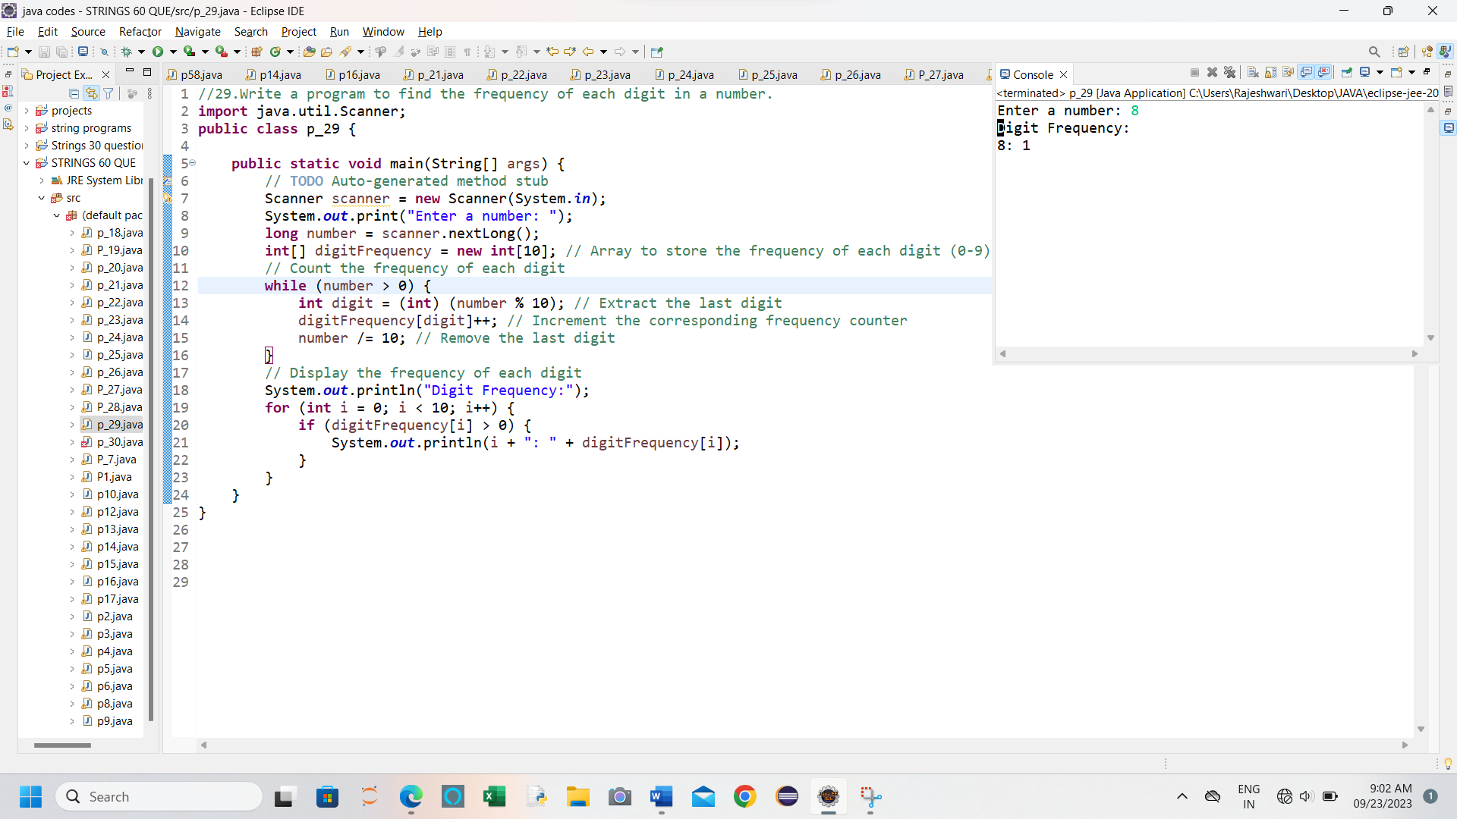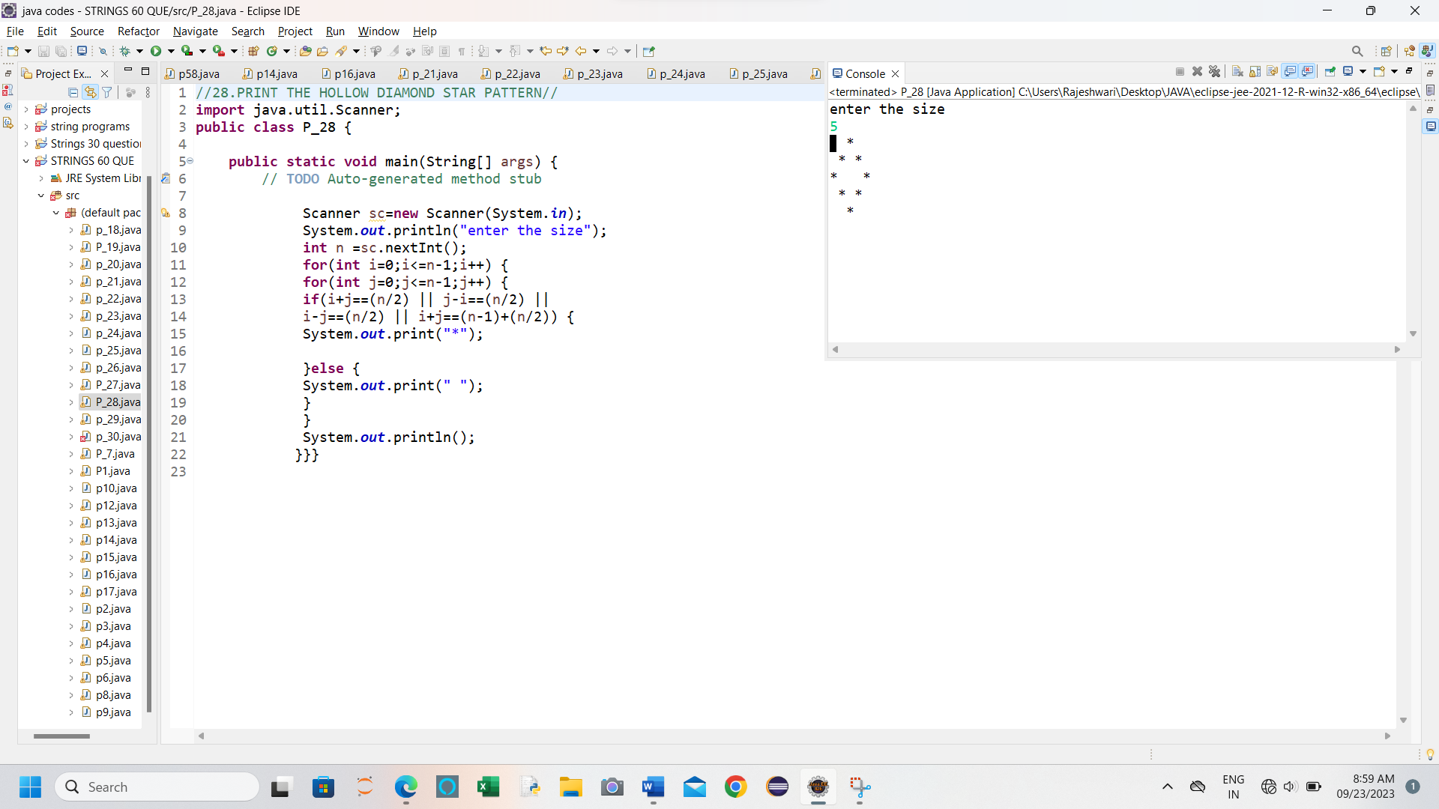

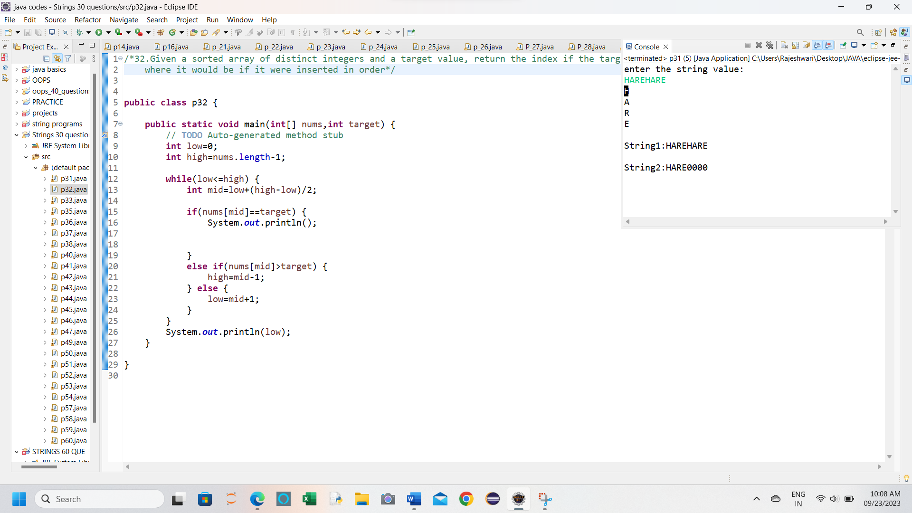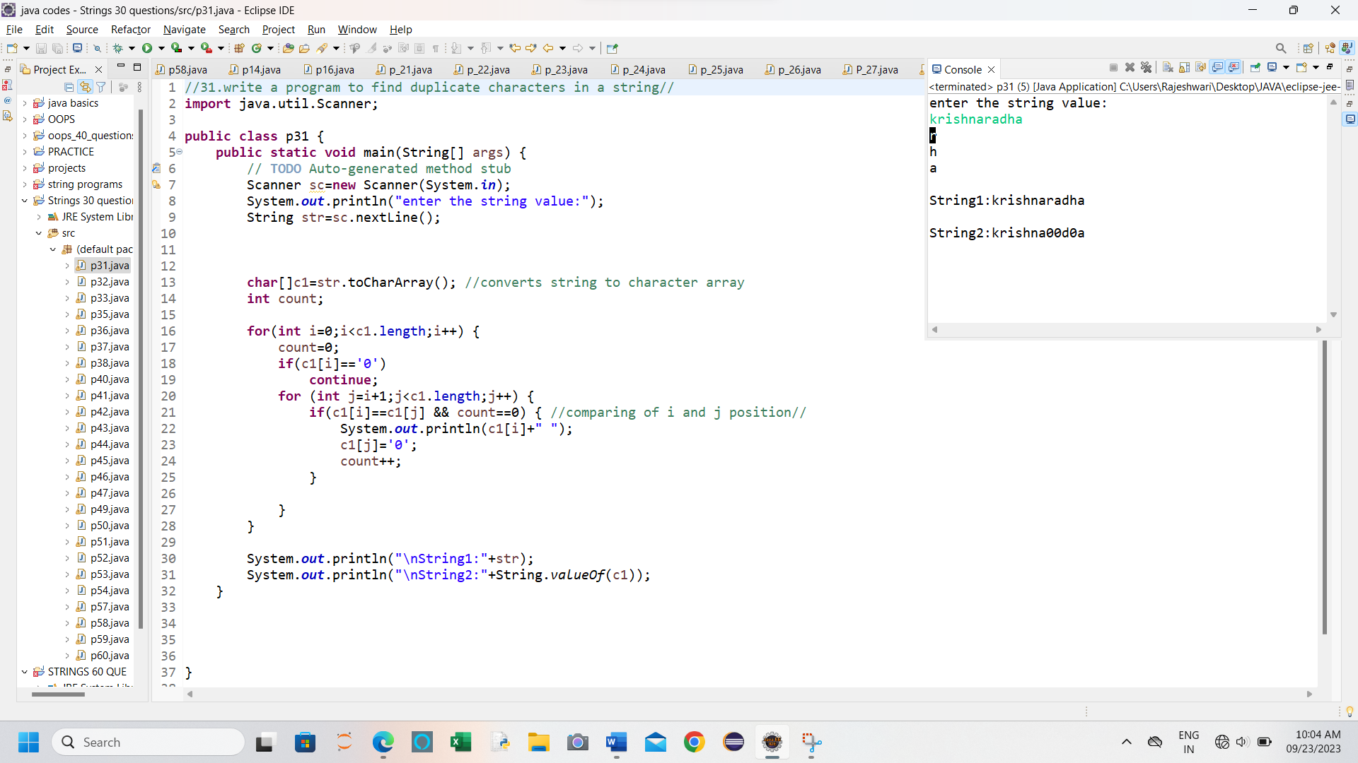

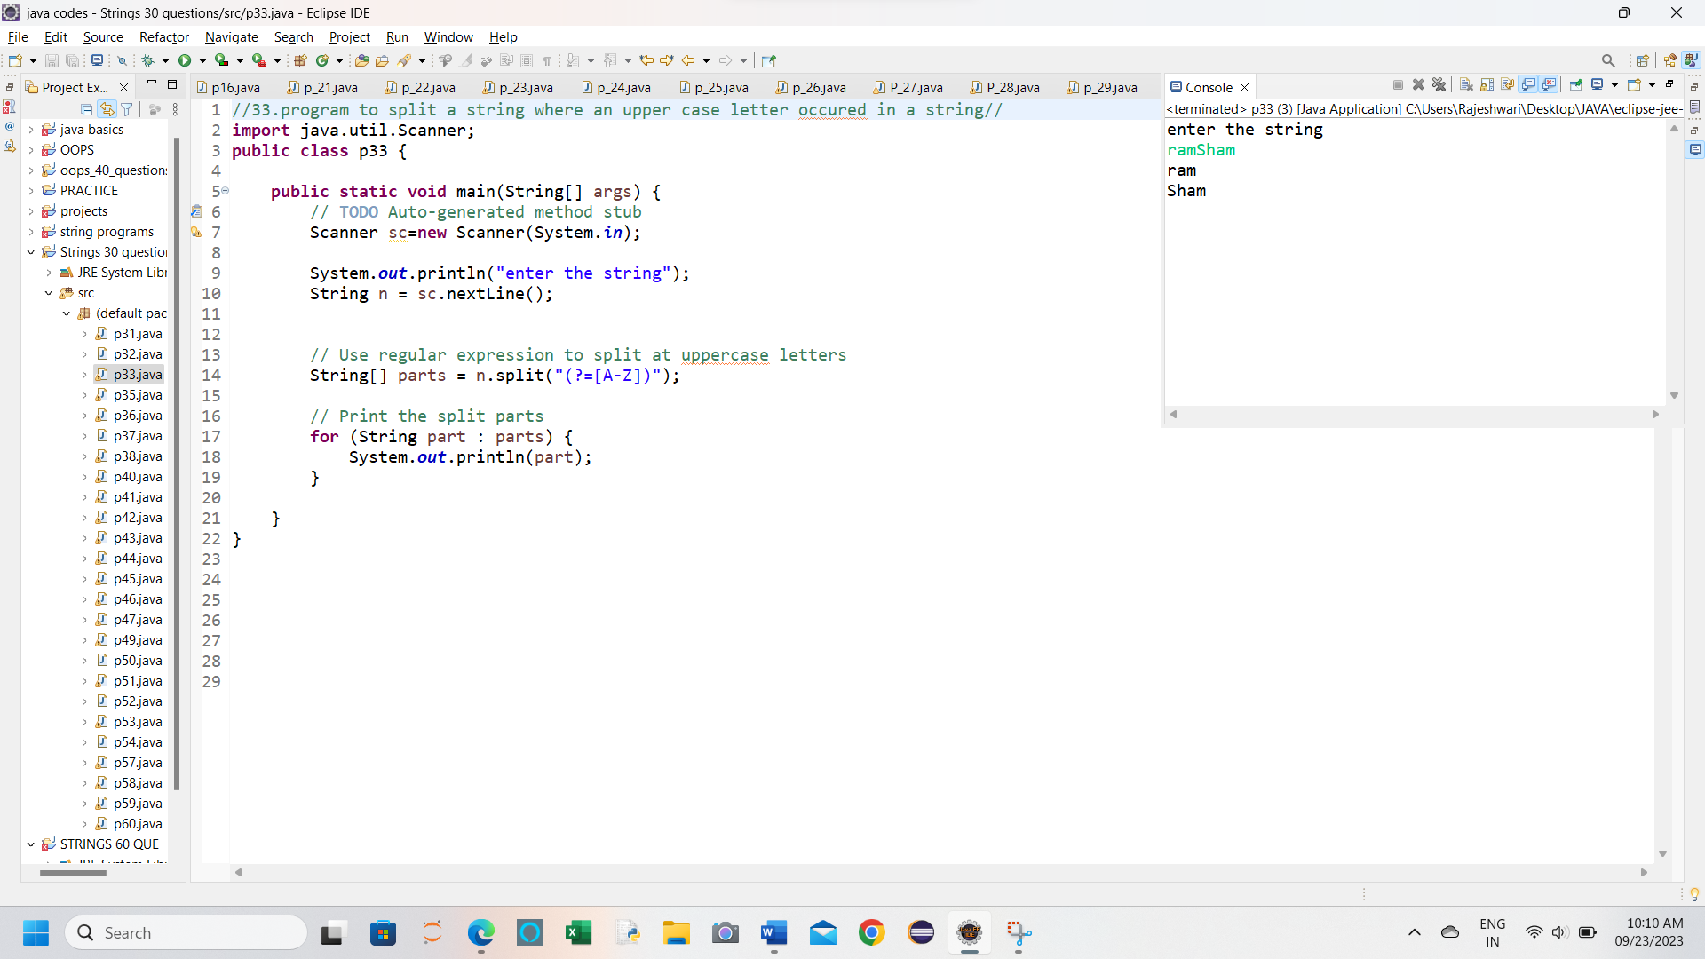

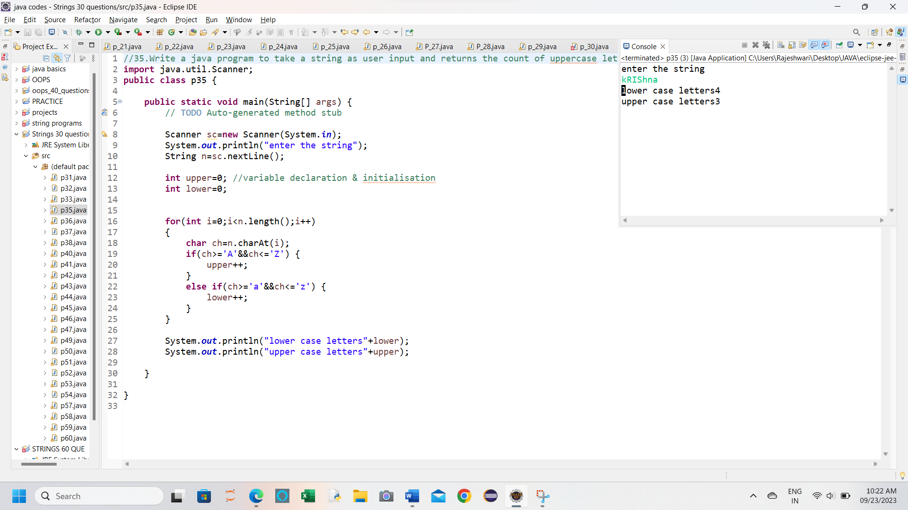

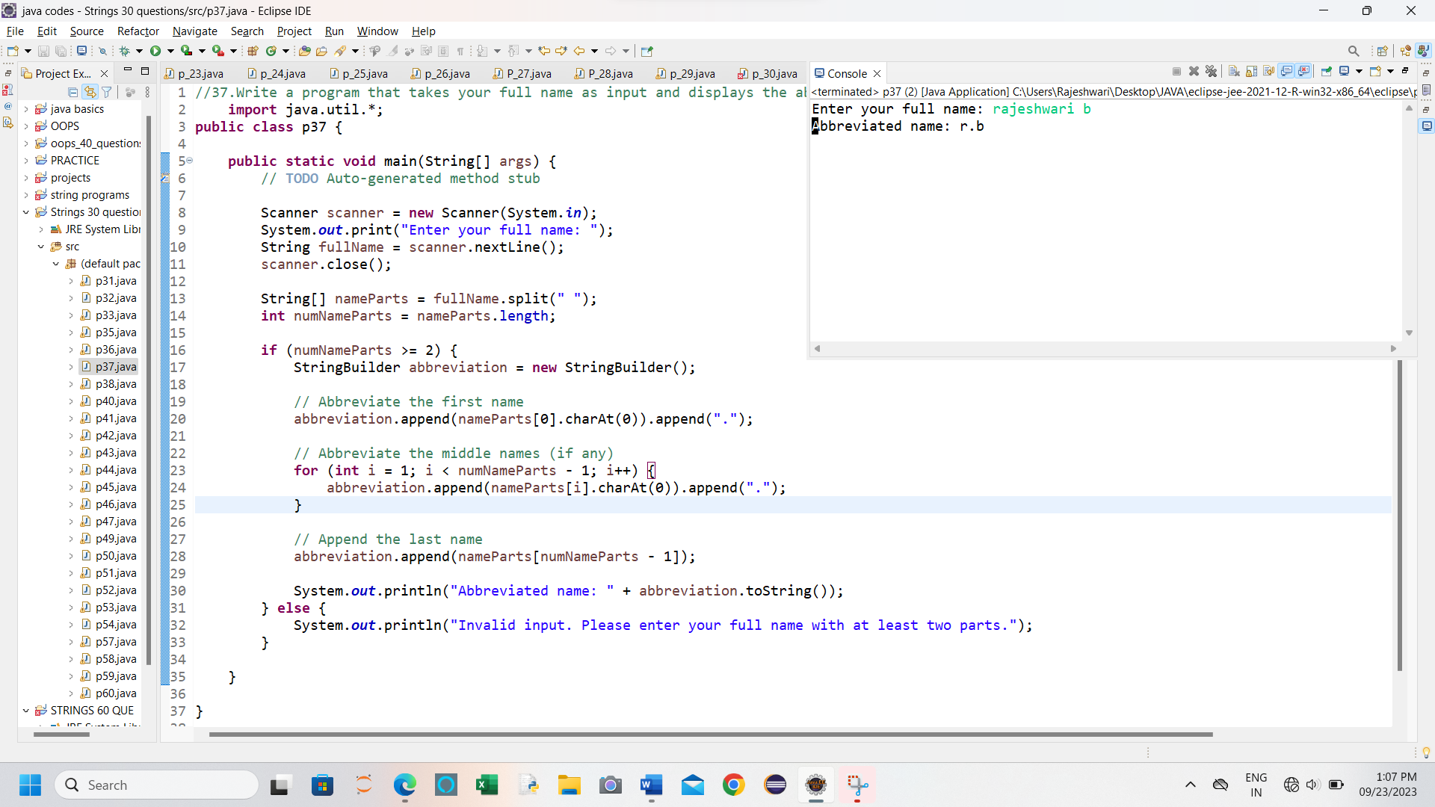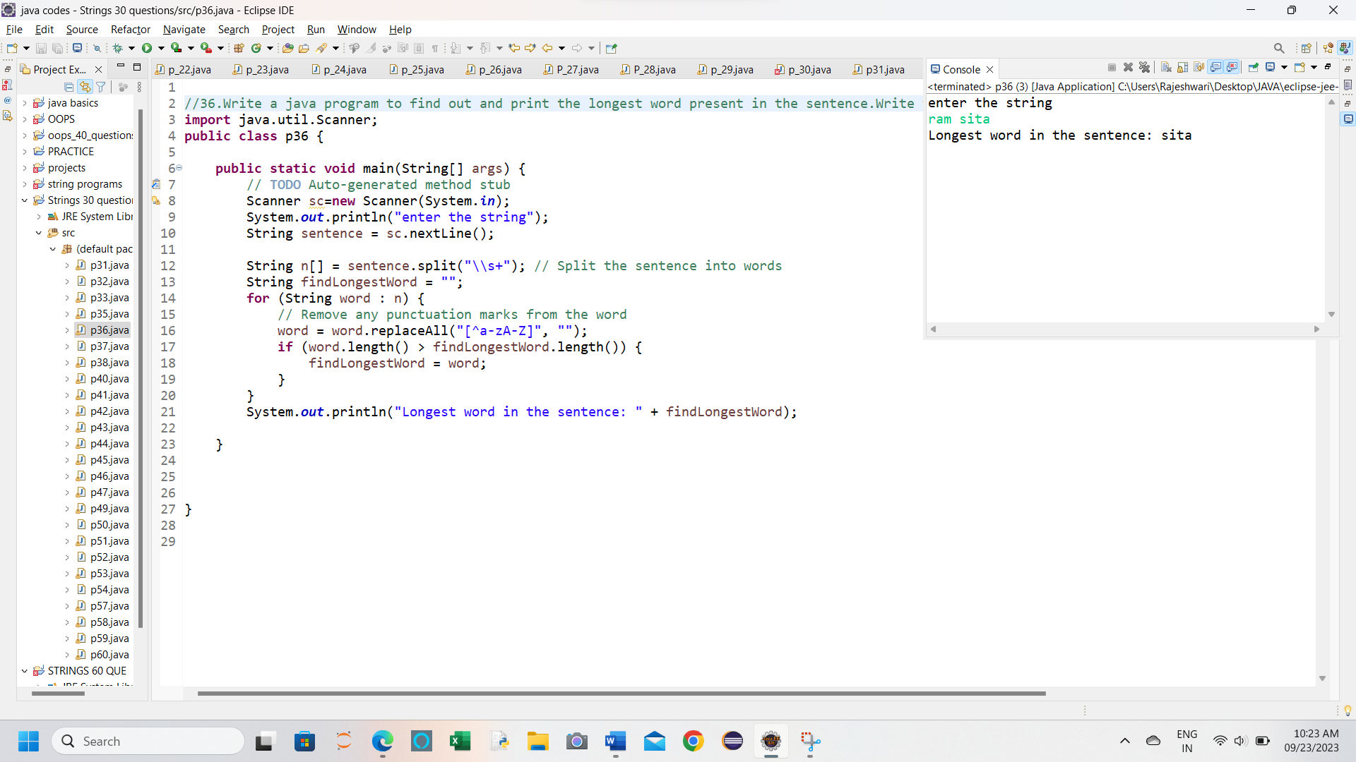

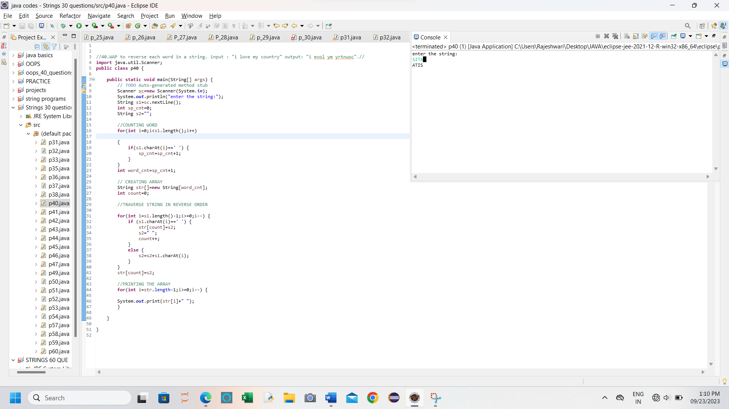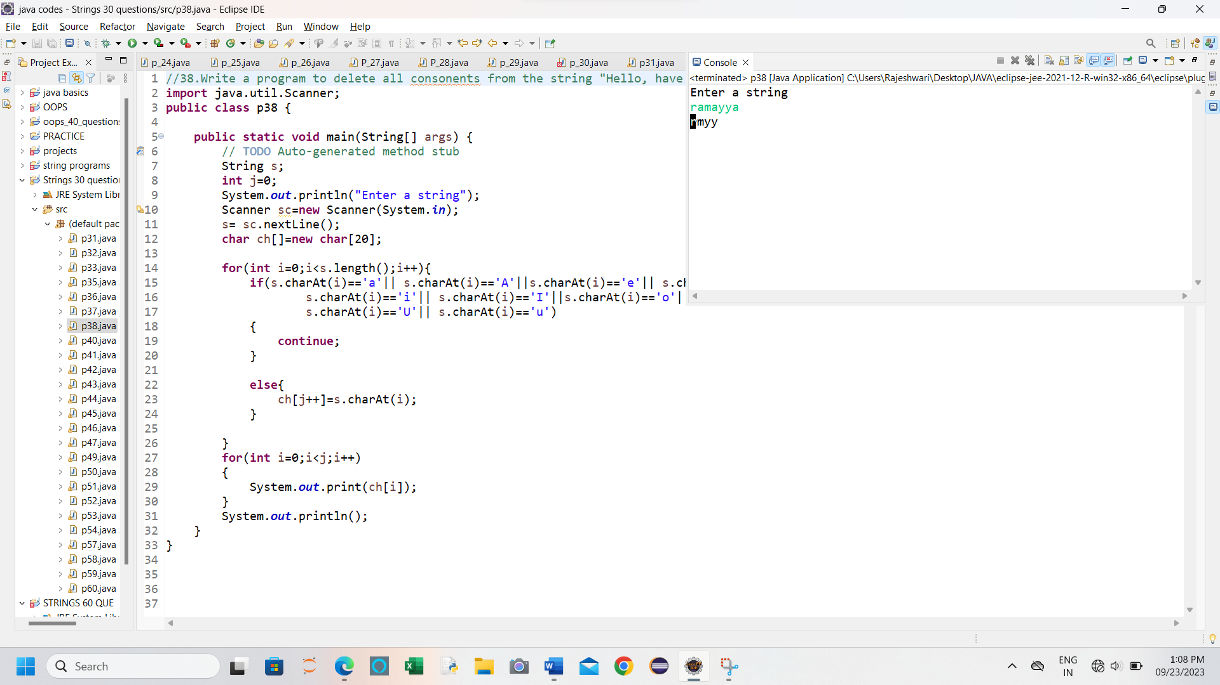

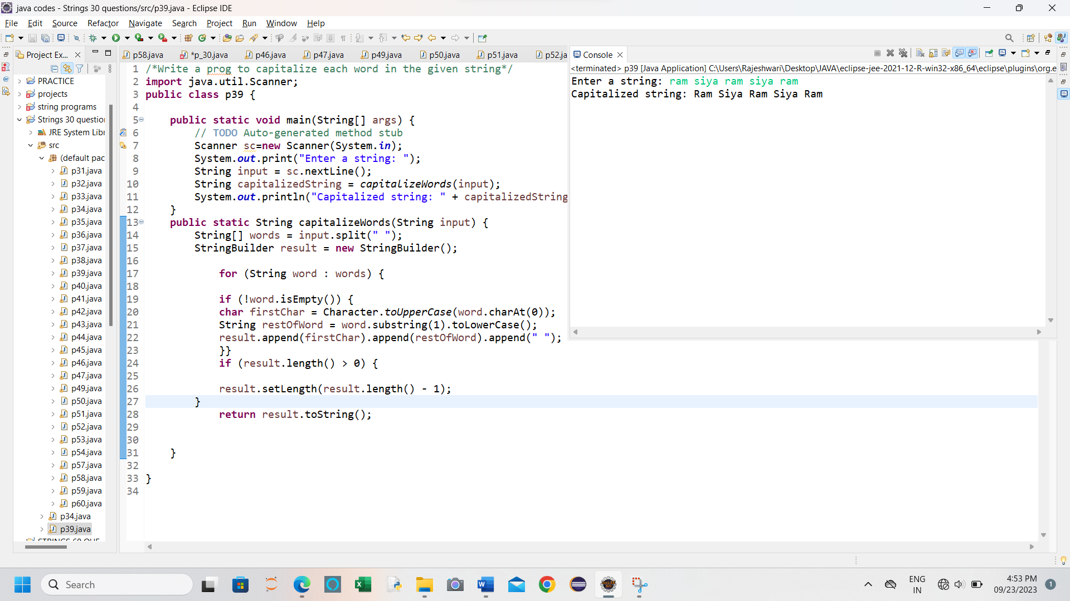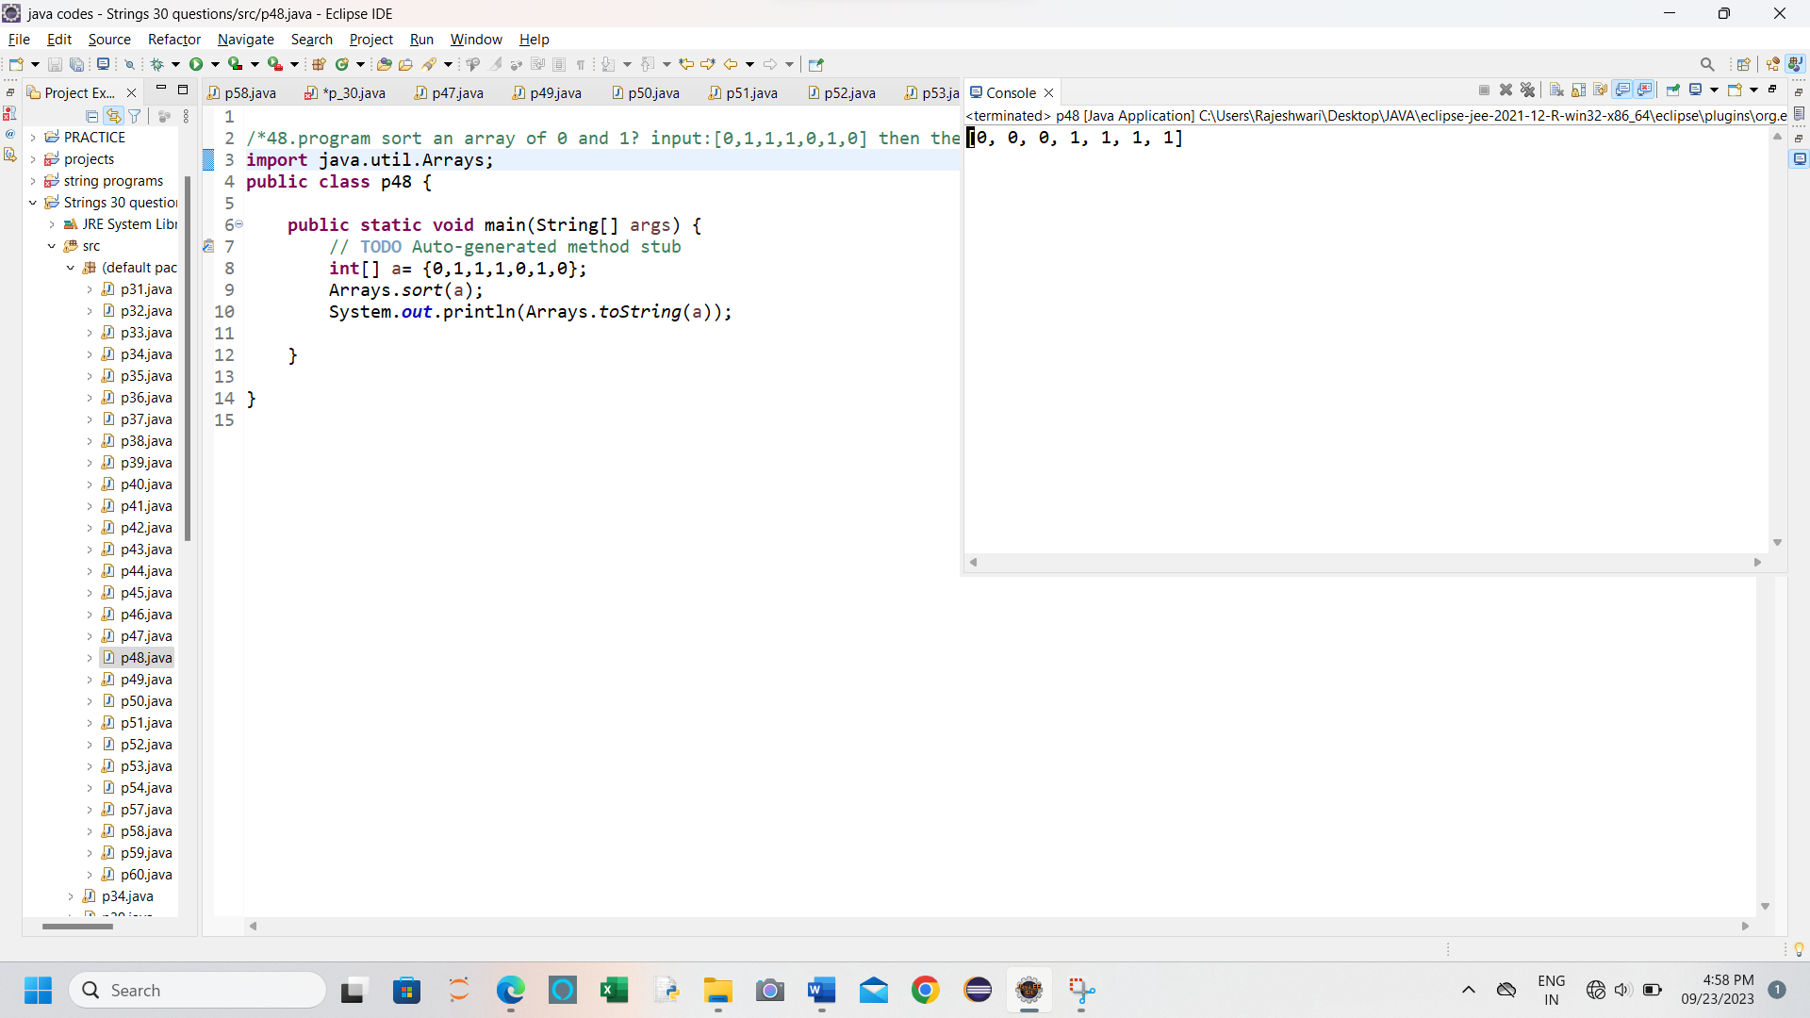

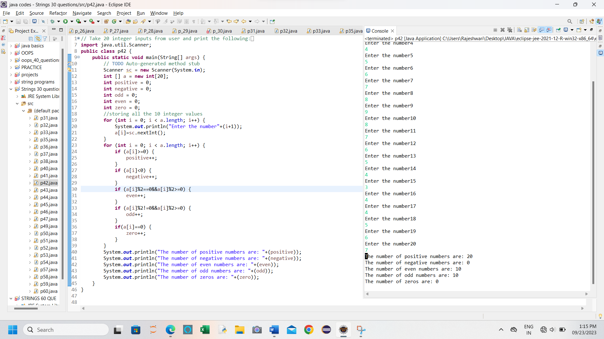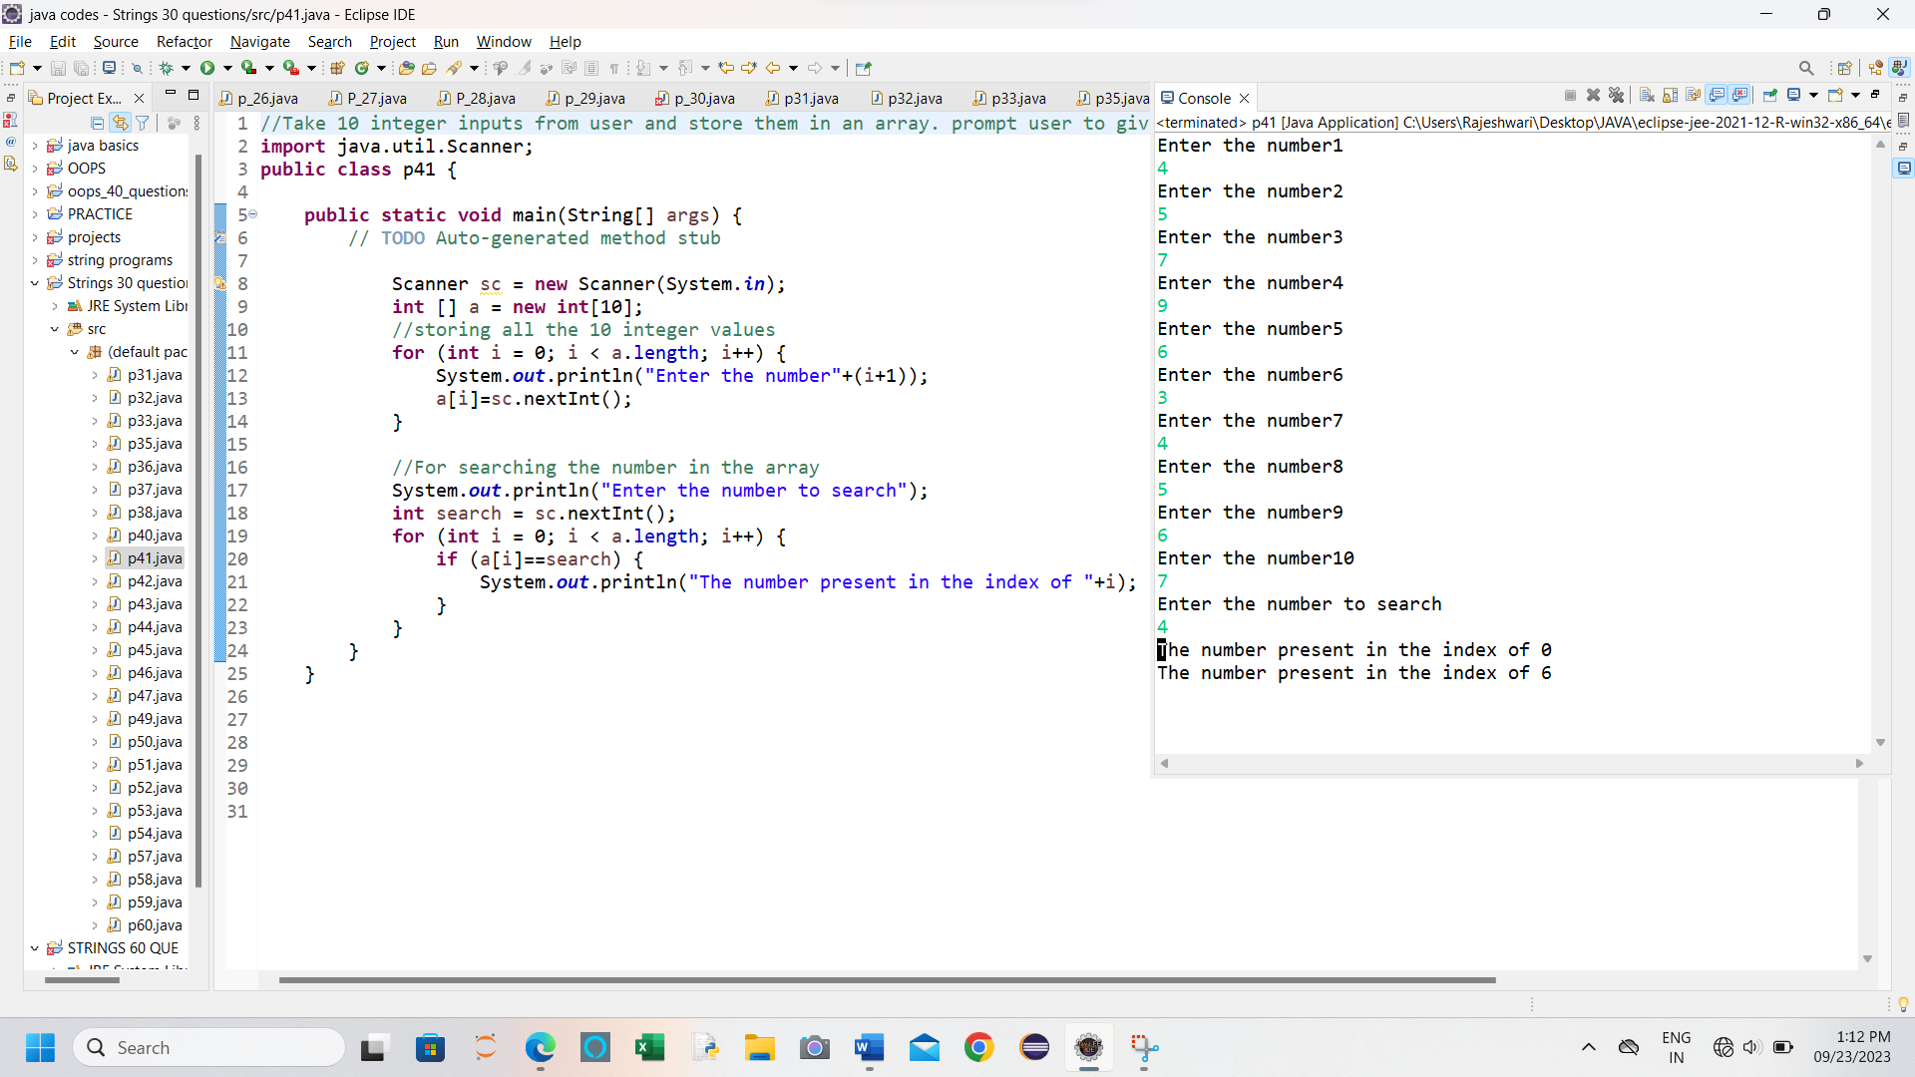

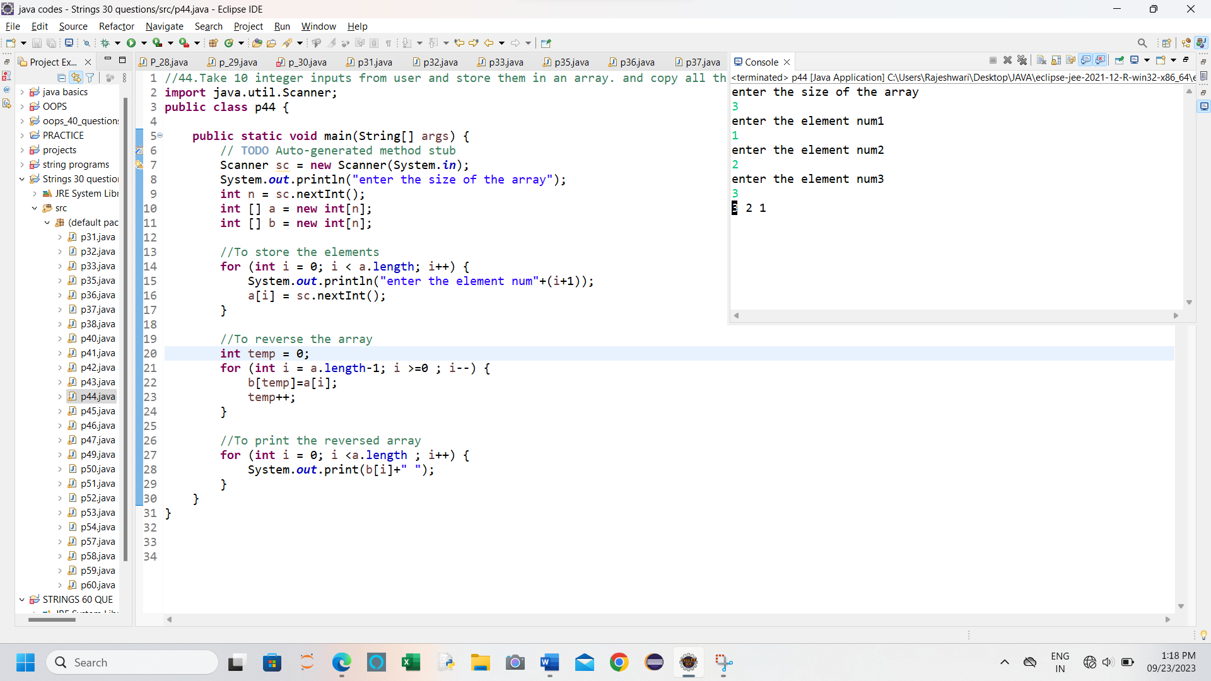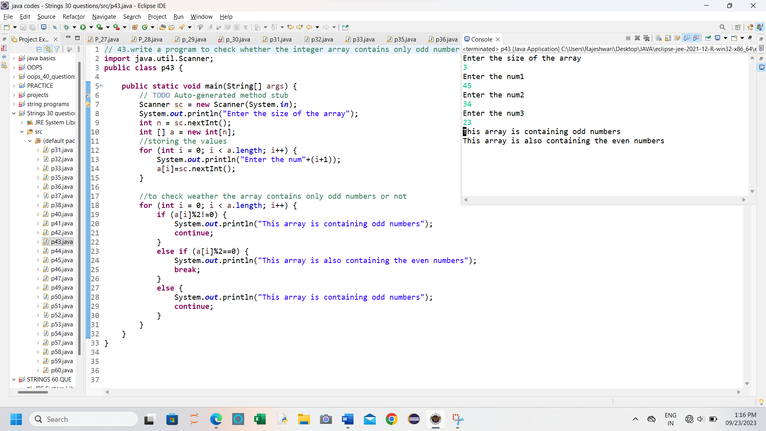

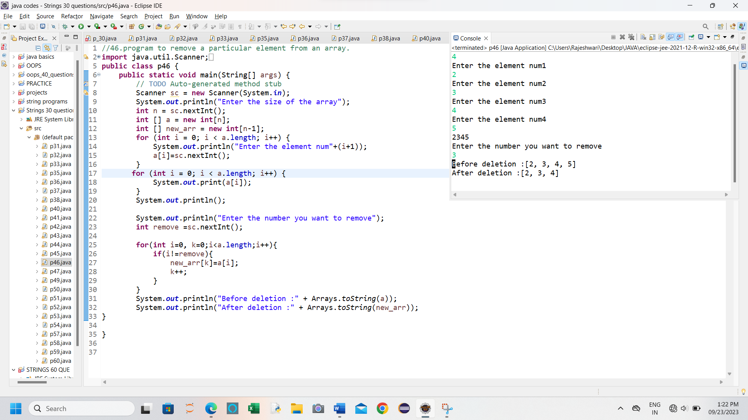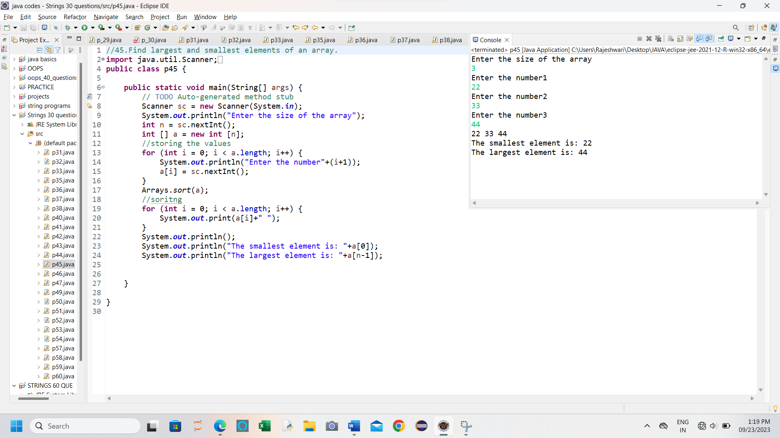

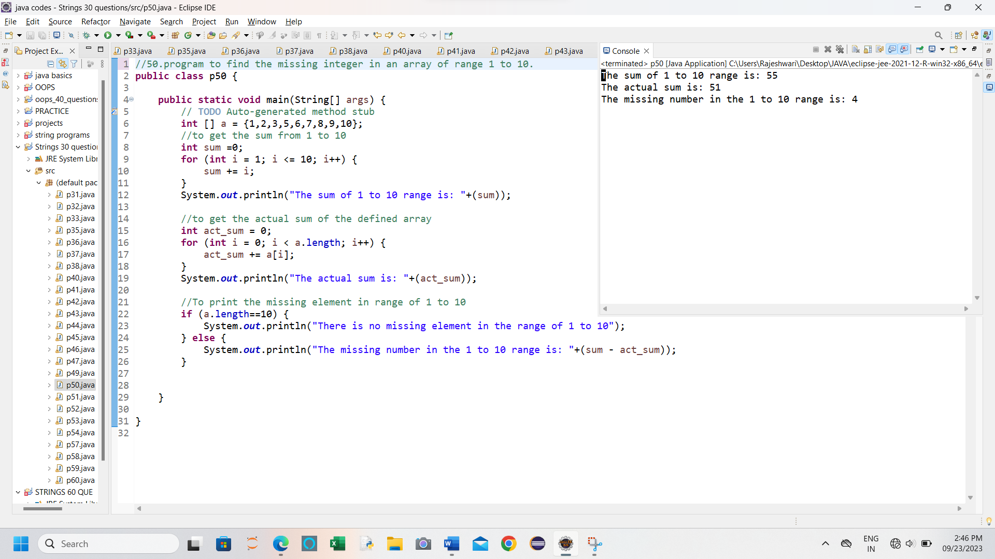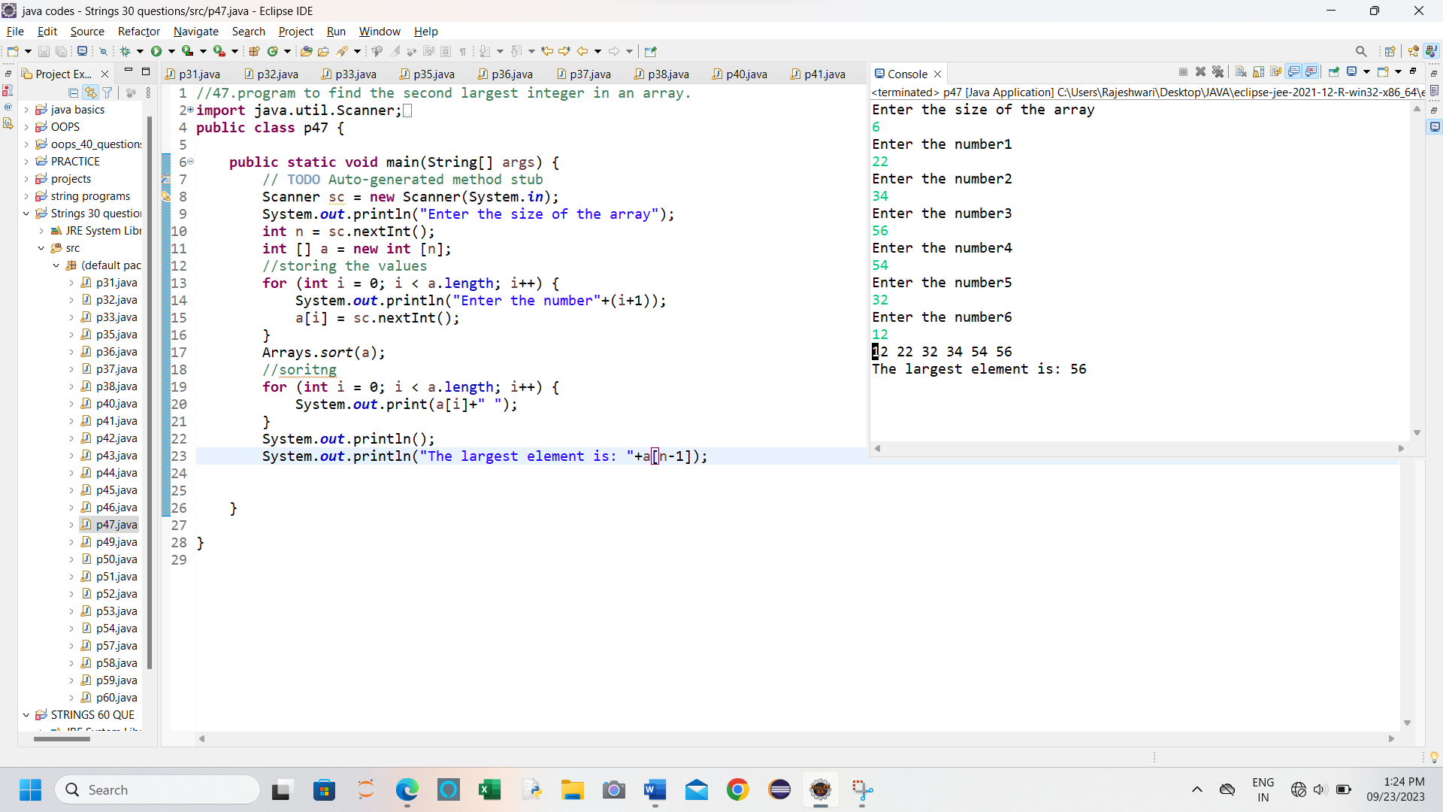

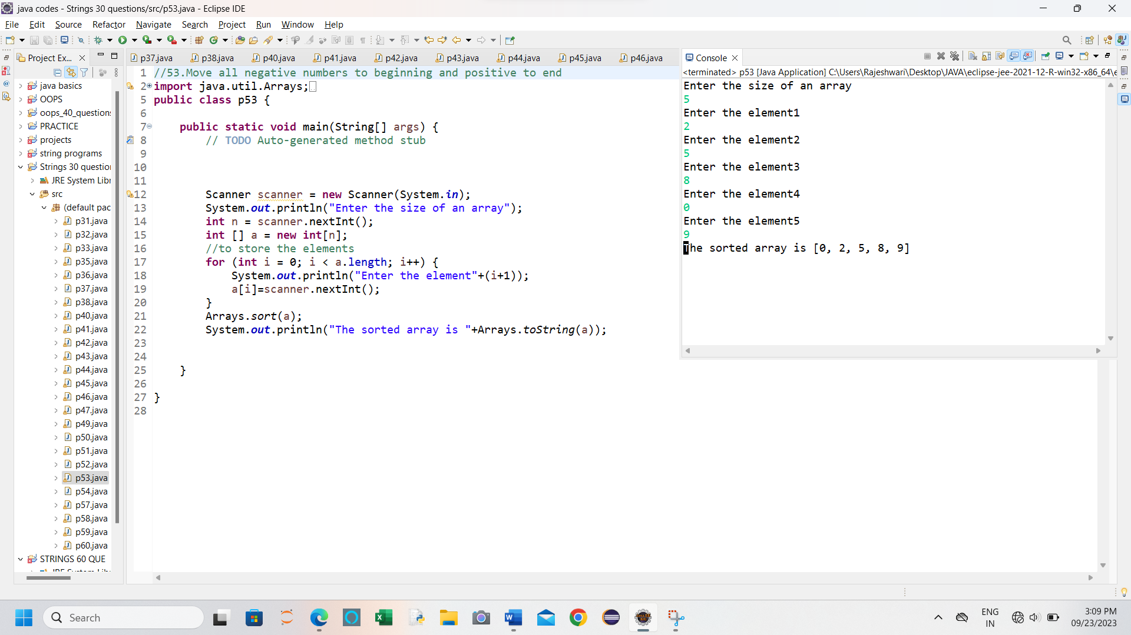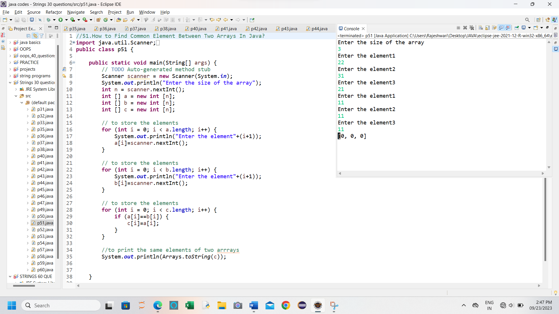

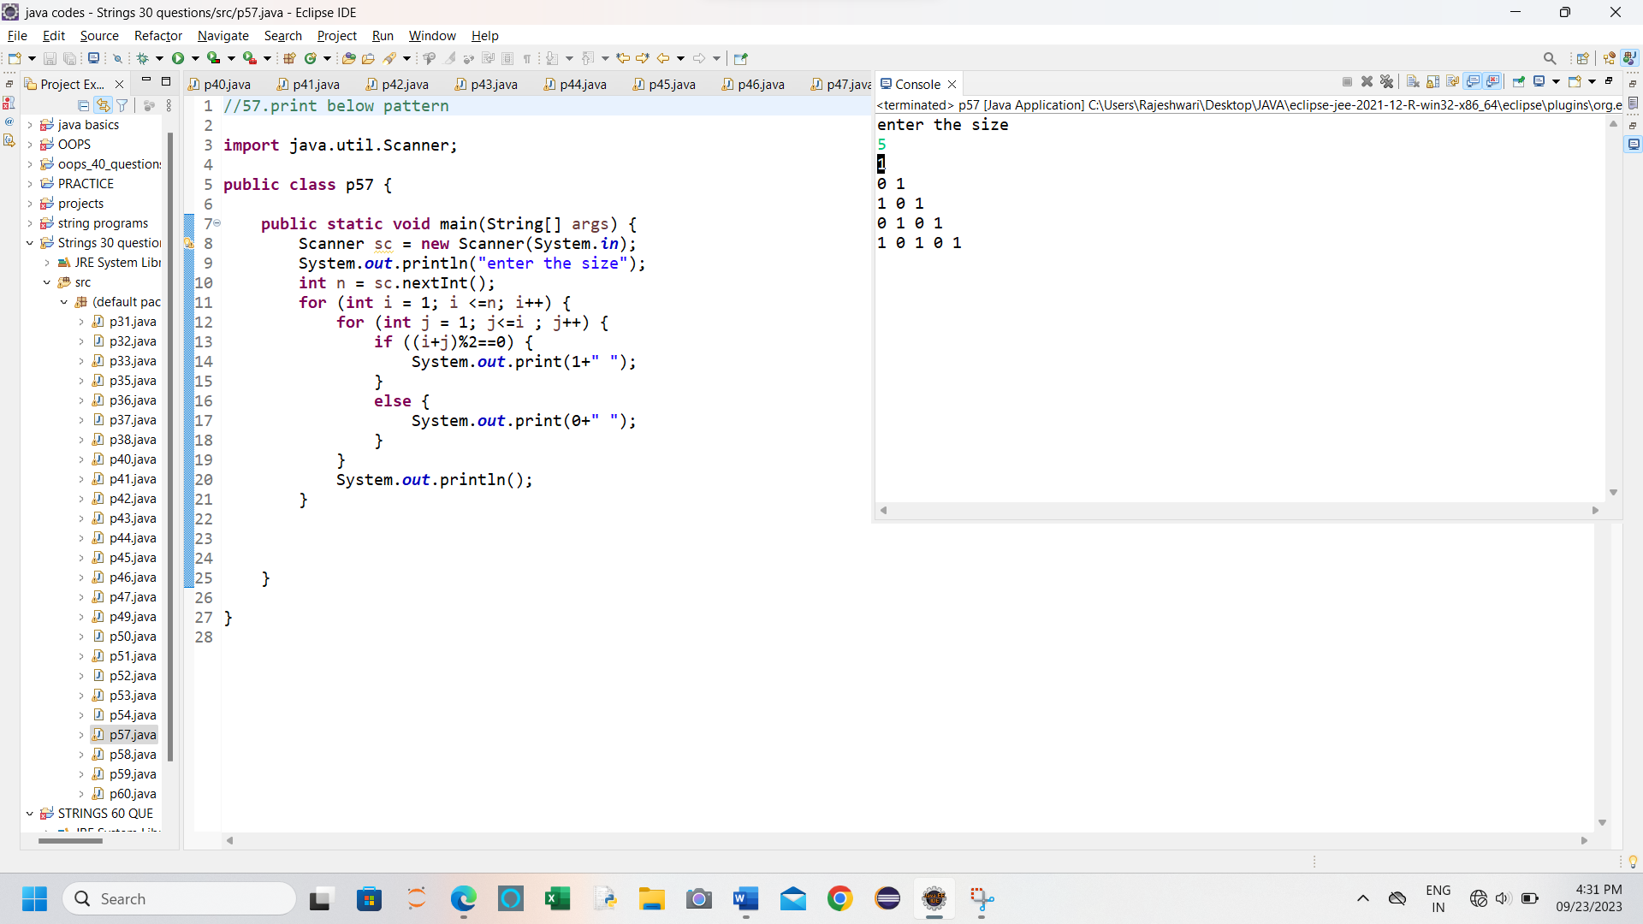

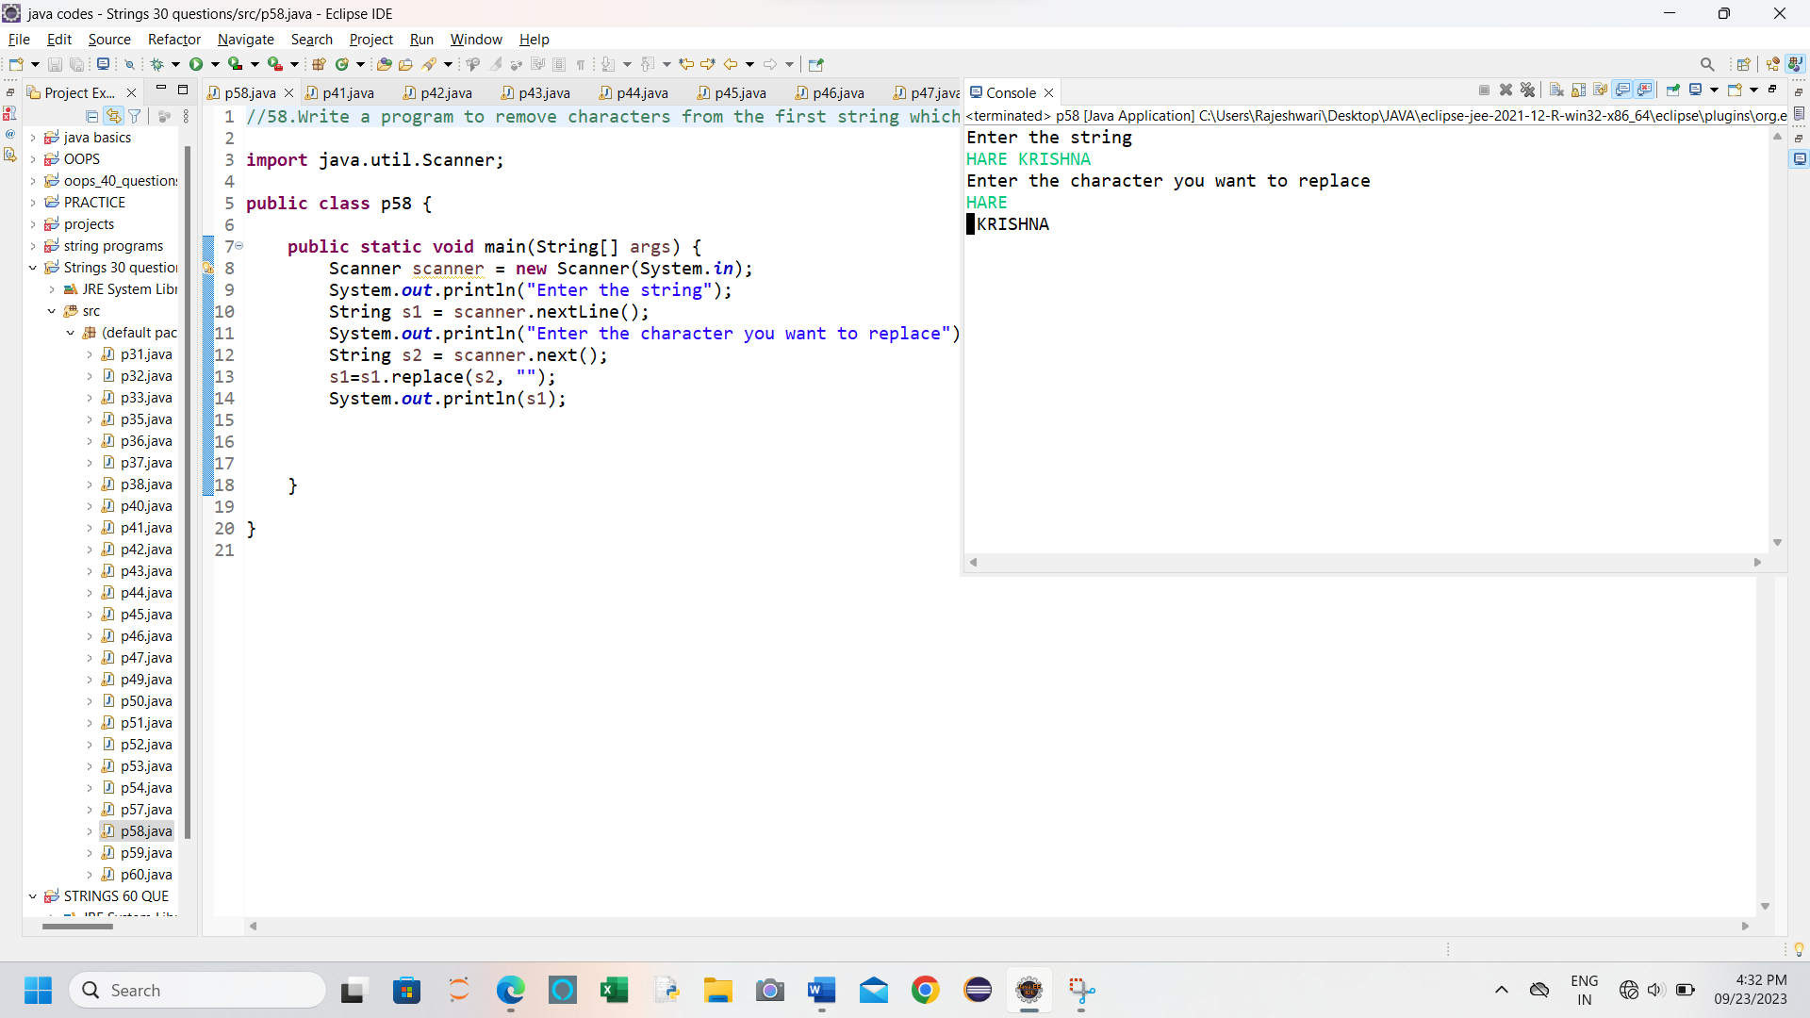

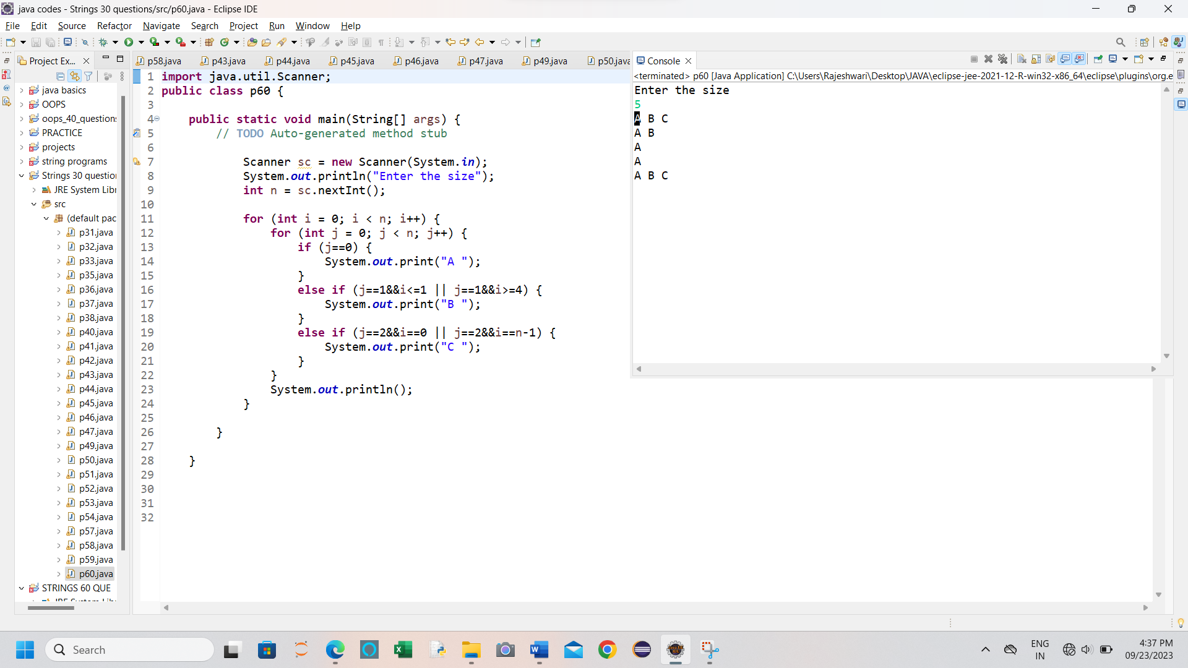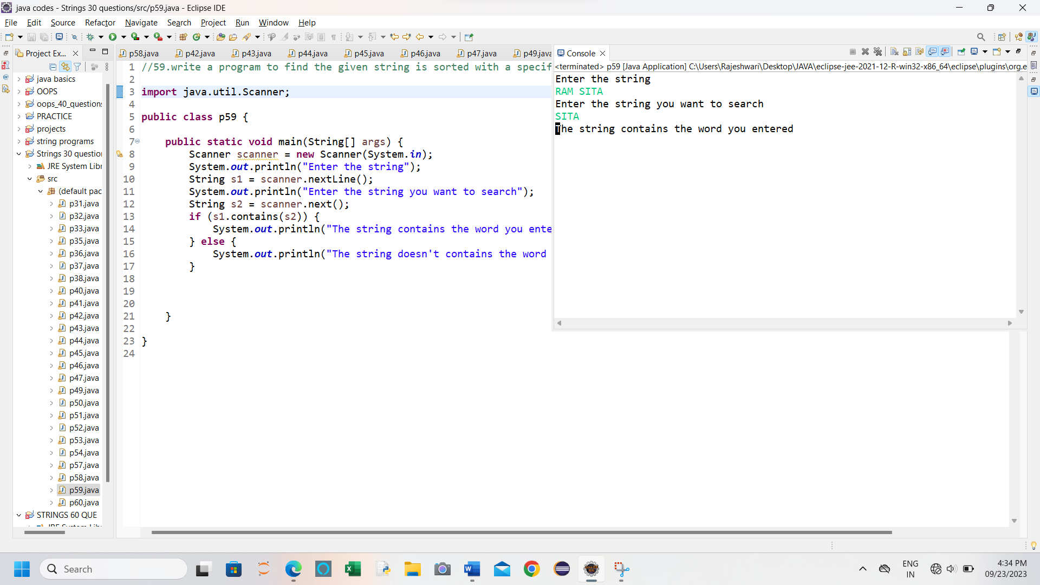

**61.** **Write a java code to solve the Dining Philosophers problem?**

**package** oops_40_questions;

**import** java.util.concurrent.Semaphore;

**class** Philosopher **extends** Thread {

**private** Semaphore leftFork;

**private** Semaphore rightFork;

**private** **int** id;

**public** Philosopher(**int** id, Semaphore leftFork, Semaphore rightFork) {

**this**.id = id;

**this**.leftFork = leftFork;

**this**.rightFork = rightFork;

}

**private** **void** think() {

System.***out***.println("Philosopher " + id + " is thinking.");

**try** {

Thread.*sleep*((**long**) (Math.*random*() * 10));

} **catch** (InterruptedException e) {

e.printStackTrace();

}

}

**private** **void** eat() {

System.***out***.println("Philosopher " + id + " is eating.");

**try** {

Thread.*sleep*((**long**) (Math.*random*() * 10));

}

**catch** (InterruptedException e) {

e.printStackTrace();

}

}

**public** **void** run() {

**while** (**true**) {

think();

**try** {

leftFork.acquire();

System.***out***.println("Philosopher " + id + " picked up the left fork.");

rightFork.acquire();

System.***out***.println("Philosopher " + id + " picked up the right fork and is now eating.");

eat();

leftFork.release();

System.***out***.println("Philosopher " + id + " released the left fork.");

rightFork.release();

System.***out***.println("Philosopher " + id + " released the right fork and is now thinking.");

} **catch** (InterruptedException e) {

e.printStackTrace();

} } }}

**public** **class** program61 {

**public** **static** **void** main(String[] args) {

**int** numPhilosophers = 5;

Semaphore[] forks = **new** Semaphore[numPhilosophers];

**for** (**int** i = 0; i < numPhilosophers; i++) {

forks[i] = **new** Semaphore(1);

}

Philosopher[] philosophers = **new** Philosopher[numPhilosophers];

**for** (**int** i = 0; i < numPhilosophers; i++) {

philosophers[i] = **new** Philosopher(i, forks[i], forks[(i + 1) % numPhilosophers]);

philosophers[i].start()}

}

}

**Output**

Philosopher 1 is thinking.

Philosopher 0 is thinking.

Philosopher 2 is thinking.

Philosopher 3 is thinking.

Philosopher 1 picked up the left fork.

Philosopher 1 picked up the right fork and is now eating.

Philosopher 1 is eating.

Philosopher 4 is thinking.

Philosopher 3 picked up the left fork.

Philosopher 3 picked up the right fork and is now eating.

Philosopher 3 is eating.

**62. Solve the 0/1 Knapsack Problem using dynamic programming in Java.**

package com.gqt.strings.project;

public class String1 {

public static int knapsack(int[] weights, int[] values, int capacity) {

int n = weights.length;

int[][] dp = new int[n + 1][capacity + 1];

for (int i = 0; i <= n; i++) {

for (int w = 0; w <= capacity; w++) {

if (i == 0 || w == 0) {

dp[i][w] = 0;

} else if (weights[i - 1] <= w) {

dp[i][w] = Math.max(values[i - 1] + dp[i - 1][w - weights[i - 1]], dp[i -

1][w]);

} else {

dp[i][w] = dp[i - 1][w];

}

}

}

return dp[n][capacity];

}

public static void main(String[] args) {

int[] weights = {2, 3, 4, 5};

int[] values = {3, 4, 5, 6};

int capacity = 5;

int maxValue = knapsack(weights, values, capacity);

System.out.println("Maximum Value: " + maxValue);

}

}

**Output**

Maximum Value: 7

**63.Write a program to solve the classic "N-Queens" problem, where you need to place N queens on an N×N chessboard such that no two queens threaten each other?(N-Queens Problem)**

**package** oops_40_questions;

**import** java.util.*;

**public** **class** program43 {

// Store all the possible answers

**static** List<List<String> > *answer* = **new** ArrayList<>();

// Print the board

**static** **void** print_board()

{

**for** (String str : *answer*.get(1)) {

**for** (Character letter : str.toCharArray())

System.***out***.print(letter + " ");

System.***out***.println();

}

**return**;

}

**static** **boolean** safe(**int** row, **int** col,

List<String> board)

{

**for** (**int** i = 0; i < board.size(); i++) {

**if** (board.get(i).charAt(col) == 'Q')

**return** **false**;

}

**int** i = row, j = col;

**while** (i >= 0 && j >= 0)

**if** (board.get(i--).charAt(j--) == 'Q')

**return** **false**;

i = row;

j = col;

**while** (i >= 0 && j < board.size())

**if** (board.get(i--).charAt(j++) == 'Q')

**return** **false**;

**return** **true**;

}

**static** **void** rec(List<String> board, **int** row)

{

**if** (row == board.size()) {

*answer*.add(board);

**return**;

}

**for** (**int** i = 0; i < board.size(); i++) {

**if** (*safe*(row, i, board)) {

List<String> temp = **new** ArrayList<>(board);

temp.set(

row,

temp.get(row).substring(0, i) + "Q"

+ temp.get(row).substring(i + 1));

*rec*(temp, row + 1);

}

}

**return**;

}

// Function to solve n queens

**static** List<List<String> > solveNQueens(**int** n)

{

String s

= **new** String(**new** **char**[n]).replace("\0", ".");

List<String> board = **new** ArrayList<>();

**for** (**int** i = 0; i < n; i++)

board.add(s);

*rec*(board, 0);

**return** *answer*;

}

**public** **static** **void** main(String[] args)

{

// Size 4x4 is taken and we can pass some other

// dimension for chess board as well

System.***out***.println(*solveNQueens*(4).size());

System.***out***.println("Out of " + *answer*.size()

+ " solutions one is following");

*print_board*();

}

}

**Output**

2

Out of 2 solutions one is following

. . Q .

Q . . .

. . . Q

. Q . .

**64**.**Define a base class "Shape" with a method "calculateArea." Create two subclasses, "Circle" and "Triangle," that inherit from "Shape" and provide their own implementations of "calculateArea." Demonstrate polymorphism by calculating the area of various shapes using an array of "Shape" objects.**

import java.util.Scanner;

// Base class

class Shape {

public double calculateArea() {

return 0.0; // Default implementation

}

}

// Subclass: Circle

class Circle extends Shape {

private double radius;

public Circle(double radius) {

this.radius = radius;

}

@Override

public double calculateArea() {

return Math.PI * radius * radius;

}

}

// Subclass: Triangle

class Triangle extends Shape {

private double base;

private double height;

public Triangle(double base, double height) {

this.base = base;

this.height = height;

}

@Override

public double calculateArea() {

return 0.5 * base * height;

}

}

public class Ques_64_shapes {

public static void main(String[] args) {

Scanner scanner = new Scanner(System.in);

System.out.println("Enter the number of shapes:");

int numShapes = scanner.nextInt();

Shape[] shapes = new Shape[numShapes];

for (int i = 0; i < numShapes; i++) {

System.out.println("Enter shape type (1 for Circle, 2 for Triangle):");

int shapeType = scanner.nextInt();

if (shapeType == 1) {

System.out.println("Enter circle radius:");

double radius = scanner.nextDouble();

shapes[i] = new Circle(radius);

} else if (shapeType == 2) {

System.out.println("Enter triangle base:");

double base = scanner.nextDouble();

System.out.println("Enter triangle height:");

double height = scanner.nextDouble();

shapes[i] = new Triangle(base, height);

}

}

System.out.println("Calculating areas:");

for (Shape shape : shapes) {

double area = shape.calculateArea();

System.out.println("Area: " + area);

}

}

}

**Output**

Enter the number of shapes: 1

Enter shape type (1 for Circle, 2 for Triangle): 1

Enter circle radius: 2.6

Calculating areas: Area: 21.237166338267002

1. **Implement a class hierarchy for a zoo simulation. Create a base class "Animal" with a method "makeSound." Then, create subclasses for different animals like "Lion," "Elephant," and "Monkey" that override the "makeSound" method to produce their specific sounds. Use polymorphism to make animals in the zoo make their sounds.**

**package** oops_40_questions;

**import** java.util.Scanner;

**class** Animal {

**public** **void** makeSound() {

System.***out***.println("The animal makes a generic sound.");

}

}

// Subclass Lion

**class** Lion **extends** Animal {

@Override

**public** **void** makeSound() {

System.***out***.println("The lion roars.");

}

}

// Subclass Elephant

**class** Elephant **extends** Animal {

@Override

**public** **void** makeSound() {

System.***out***.println("The elephant trumpets.");

}

}

// Subclass Monkey

**class** Monkey **extends** Animal {

@Override

**public** **void** makeSound() {

System.***out***.println("The monkey chatters.");

}

}

**class** zoo{

**void** permit(Animal ref) {

ref.makeSound();

}

}

**public** **class** program65 {

**public** **static** **void** main(String[] args) {

Scanner scanner = **new** Scanner(System.***in***);

System.***out***.println("******Welcome to the Zoo Simulation!******");

Lion l = **new** Lion();

Elephant e = **new** Elephant();

Monkey m = **new** Monkey();

zoo z= **new** zoo();

z.permit(l);

z.permit(e);

z.permit(m);

}

}

**Output**

******Welcome to the Zoo Simulation*****

The lion roars.

The elephant trumpets.

The monkey chatters.

1. **Develop a banking system with a base class "Account" and subclasses "SavingsAccount" and "CheckingAccount." Each account type should have a method "calculateInterest" that calculates interest differently.**

**Demonstrate polymorphism by calling the "calculateInterest" method on both account types.**

**package** oops_40_questions;

**import** java.util.Scanner;

//Base class

**class** Account {

**protected** **double** balance;

**public** Account(**double** balance) {

**this**.balance = balance;

}

**public** **void** deposit(**double** amount) {

balance += amount;

}

**public** **void** withdraw(**double** amount) {

**if** (amount <= balance) {

balance -= amount;

} **else** {

System.***out***.println("Insufficient funds");

}

}

**public** **void** displayBalance() {

System.***out***.println("Current balance: $" + balance);

}

**public** **void** calculateInterest() {

System.***out***.println("Base Account - Interest calculation method");

}

}

//Subclass for Savings Account

**class** SavingsAccount **extends** Account {

**public** SavingsAccount(**double** balance) {

**super**(balance);

}

@Override

**public** **void** calculateInterest() {

**double** interest = balance * 0.03; // Example: 3% annual interest

balance += interest;

System.***out***.println("Savings Account - Interest calculated: $" + interest);

}

}

//Subclass for Checking Account

**class** CheckingAccount **extends** Account {

**public** CheckingAccount(**double** balance) {

**super**(balance);

}

@Override

**public** **void** calculateInterest() {

System.***out***.println("Checking Account - No interest is calculated");

}

}

**public** **class** program66 {

**public** **static** **void** main(String[] args) {

Scanner scanner = **new** Scanner(System.***in***);

System.***out***.println("Welcome to the Simple Banking System!");

System.***out***.print("Enter initial balance for Savings Account: ");

**double** savingsBalance = scanner.nextDouble();

System.***out***.print("Enter initial balance for Checking Account: ");

**double** checkingBalance = scanner.nextDouble();

SavingsAccount savingsAccount = **new** SavingsAccount(savingsBalance);

CheckingAccount checkingAccount = **new** CheckingAccount(checkingBalance);

System.***out***.print("Enter the amount to deposit in Savings Account: ");

**double** depositAmount = scanner.nextDouble();

savingsAccount.deposit(depositAmount);

System.***out***.print("Enter the amount to withdraw from Checking Account: ");

**double** withdrawAmount = scanner.nextDouble();

checkingAccount.withdraw(withdrawAmount);

// Demonstrate polymorphism

Account[] accounts = {savingsAccount, checkingAccount};

**for** (Account account : accounts) {

account.displayBalance();

account.calculateInterest();

}

}

}

**Output**

Welcome to the Simple Banking System!

Enter initial balance for Savings Account:

2000

Enter initial balance for Checking Account: 500

Enter the amount to deposit in Savings Account: 500

Enter the amount to withdraw from Checking Account: 500

Current balance: $2500.0

Savings Account - Interest calculated: $75.0

Current balance: $0.0

Checking Account - No interest is calculated

1. **Write a java code to verify performance of StringBuffer and StringBuilder classes.**

public class StringBufferVsStringBuilderPerformance {

public static void main(String[] args) {

int iterations = 100000;

String textToAppend = "Hello, World!";

long startTime, endTime;

// Using StringBuffer

StringBuffer stringBuffer = new StringBuffer();

startTime = System.nanoTime();

for (int i = 0; i < iterations; i++) {

stringBuffer.append(textToAppend);

}

endTime = System.nanoTime();

long stringBufferTime = endTime - startTime;

// Using StringBuilder

StringBuilder stringBuilder = new StringBuilder();

startTime = System.nanoTime();

for (int i = 0; i < iterations; i++) {

stringBuilder.append(textToAppend);

}

endTime = System.nanoTime();

long stringBuilderTime = endTime - startTime;

System.out.println("StringBuffer Time: " + stringBufferTime + " nanoseconds");

System.out.println("StringBuilder Time: " + stringBuilderTime + " nanoseconds");

}

}

**Output**

StringBuffer Time: 15076400 nanoseconds

StringBuilder Time: 6554100 nanoseconds

1. **Build a simple media player application with a base class "MediaPlayer" and subclasses "AudioPlayer" and "VideoPlayer." Each subclass should have a method "play" to display messages like "Playing audio" or "Playing video." Utilize polymorphism to play different media types.**

**package** oops_40_questions;

**import** java.util.Scanner;

//Base class MediaPlayer

**class** MediaPlayer {

**public** **void** play() {

// Default play method for all media types

System.***out***.println("Playing media...");

}

}

//Subclass AudioPlayer

**class** AudioPlayer **extends** MediaPlayer {

@Override

**public** **void** play() {

System.***out***.println("Playing audio...");

}

}

//Subclass VideoPlayer

**class** VideoPlayer **extends** MediaPlayer {

@Override

**public** **void** play() {

System.***out***.println("Playing video...");

}

}

**class** player{

**void** permit(MediaPlayer ref) {

ref.play();

}

}

**public** **class** program68 {

**public** **static** **void** main(String[] args) {

Scanner scanner = **new** Scanner(System.***in***);

System.***out***.println(" media type");

AudioPlayer ap = **new** AudioPlayer();

VideoPlayer vp = **new** VideoPlayer();

player p = **new** player();

p.permit(ap);

p.permit(vp);

}

}

**Output**

media type

Playing audio...

Playing video...

1. **Create a Java class hierarchy for geometric shapes, including a base class "Shape" with methods for calculating area and perimeter. Implement two subclasses, "Circle" and "Rectangle," that inherit from the "Shape" class and provide their own implementations of area and perimeter calculations.(Inheritance)**

**package** oops_40_questions;

//Base class Shape5

**abstract** **class** Shape5 {

**abstract** **double** calculateArea();

**abstract** **double** calculatePerimeter();

}

//Subclass Circle5

**class** Circle5 **extends** Shape5 {

**private** **double** radius;

**public** Circle5(**double** radius) {

**this**.radius = radius;

}

@Override

**double** calculateArea() {

**return** Math.***PI*** * radius * radius;

}

@Override

**double** calculatePerimeter() {

**return** 2 * Math.***PI*** * radius;

}

}

//Subclass Rectangle

**class** Rectangle **extends** Shape5 {

**private** **double** width;

**private** **double** height;

**public** Rectangle(**double** width, **double** height) {

**this**.width = width;

**this**.height = height;

}

@Override

**double** calculateArea() {

**return** width * height;

}

@Override

**double** calculatePerimeter() {

**return** 2 * (width + height);

}

}

**public** **class** program69 {

**public** **static** **void** main(String[] args) {

Circle5 Circle5 = **new** Circle5(5.0);

Rectangle rectangle = **new** Rectangle(4.0, 6.0);

System.***out***.println("Circle5 Area: " + Circle5.calculateArea());

System.***out***.println("Circle5 Perimeter: " + Circle5.calculatePerimeter());

System.***out***.println("Rectangle Area: " + rectangle.calculateArea());

System.***out***.println("Rectangle Perimeter: " + rectangle.calculatePerimeter());

}

}

**Output**

Circle5 Area: 78.53981633974483

Circle5 Perimeter: 31.41592653589793

Rectangle Area: 24.0

Rectangle Perimeter: 20.0

1. **Define a class "Animal" with properties like name, age, and sound. Create two subclasses, "Dog" and "Cat," that inherit from the "Animal" class. Add methods to both subclasses to make them produce their respective sounds. Demonstrate polymorphism by creating instances of each subclass and calling the sound methods. (Inheritance)**

**package** oops_40_questions;

**class** Animall {

**private** String name;

**private** **int** age;

**private** String sound;

**public** Animall(String name, **int** age, String sound) {

**this**.name = name;

**this**.age = age;

**this**.sound = sound;

}

**public** String getName() {

**return** name;

}

**public** **int** getAge() {

**return** age;

}

**public** **void** makeSound() {

System.***out***.println(name + " makes a sound: " + sound);

}

}

// The Dog subclass that inherits from Animall

**class** Dog **extends** Animall {

**public** Dog(String name, **int** age) {

**super**(name, age, "Woof!");

}

}

// The Cat subclass that inherits from Animall

**class** Cat **extends** Animall {

**public** Cat(String name, **int** age) {

**super**(name, age, "Meow!");

}

}

**public** **class** program70 {

**public** **static** **void** main(String[] args) {

// Create instances of Dog and Cat

Dog myDog = **new** Dog("shadow", 3);

Cat myCat = **new** Cat("monty", 5);

// Demonstrate polymorphism by calling the makeSound method

Animall[] Animalls = {myDog, myCat};

**for** (Animall Animall : Animalls) {

System.***out***.println(Animall.getName() + " is " + Animall.getAge() + " years old.");

Animall.makeSound();

System.***out***.println();

}

}

}

**Output**

shadowis 3 years old.

shadowmakes a sound: Woof!

Monty is 5 years old.

monty makes a sound: Meow!

**71.Design a class hierarchy for a banking system. Create a base class**

**"Account" with fields for account number, account holder name, and**

**balance. Implement two subclasses, "SavingsAccount" and**

**"CheckingAccount," that inherit from the "Account" class. Add methods for deposit, withdrawal, and account-specific behaviors. (Inheritance)**

package com.gqt.strings.project;

//Base class Account

class Account {

private int accountNumber;

private String accountHolderName;

private double balance;

public Account(int accountNumber, String accountHolderName, double balance) {

this.accountNumber = accountNumber;

this.accountHolderName = accountHolderName;

this.setBalance(balance);

}

public int getAccountNumber() {

return accountNumber;

}

public String getAccountHolderName() {

return accountHolderName;

}

public double getBalance() {

return balance;

}

public void deposit(double amount) {

if (amount > 0) {

setBalance(getBalance() + amount);

System.out.println("Deposited $" + amount);

} else {

System.out.println("Invalid deposit amount.");

}

}

public void withdraw(double amount) {

if (amount > 0 && amount <= getBalance()) {

setBalance(getBalance() - amount);

System.out.println("Withdrawn $" + amount);

} else {

System.out.println("Invalid withdrawal amount or insufficient balance.");

}

}

public void displayAccountInfo() {

System.out.println("Account Number: " + accountNumber);

System.out.println("Account Holder: " + accountHolderName);

System.out.println("Balance: $" + getBalance());

}

public void setBalance(double balance) {

this.balance = balance;

}

}

//Subclass SavingsAccount

class SavingsAccount extends Account {

private double interestRate;

public SavingsAccount(int accountNumber, String accountHolderName, double balance, double

interestRate) {

super(accountNumber, accountHolderName, balance);

this.interestRate = interestRate;

}

public void applyInterest() {

double interest = getBalance() * interestRate;

deposit(interest);

System.out.println("Interest applied: $" + interest);

}

}

//Subclass CheckingAccount

class CheckingAccount extends Account {

private double overdraftLimit;

public CheckingAccount(int accountNumber, String accountHolderName, double balance, double

overdraftLimit) {

super(accountNumber, accountHolderName, balance);

this.overdraftLimit = overdraftLimit;

}

@Override

public void withdraw(double amount) {

if (amount > 0 && amount <= (getBalance() + overdraftLimit)) {

setBalance(getBalance() - amount);

System.out.println("Withdrawn $" + amount);

} else {

System.out.println("Invalid withdrawal amount or exceeded overdraft limit.");

}

}

}

public class String1 {

public static void main(String[] args) {

// Create a savings account

SavingsAccount savingsAccount = new SavingsAccount(12345, "John Doe", 1000.0, 0.05);

savingsAccount.displayAccountInfo();

savingsAccount.deposit(500.0);

savingsAccount.applyInterest();

savingsAccount.withdraw(200.0);

savingsAccount.displayAccountInfo();

// Create a checking account

CheckingAccount checkingAccount = new CheckingAccount(67890, "Jane Smith", 500.0,

100.0);

checkingAccount.displayAccountInfo();

checkingAccount.deposit(200.0);

checkingAccount.withdraw(800.0); // Attempt to exceed overdraft limit

checkingAccount.displayAccountInfo();

}

}

**Output**

Account1 Number: 6771495851

Account1 Holder: Alice

Balance: $1000.0

Deposited $200.0 into Account1 6771495851

Interest applied to Account1 6771495851

Account1 Number: 6771495851

Account1 Holder: Alice

Balance: $1260.0

Account1 Number: 2286213111

Account1 Holder: Bob

Balance: $500.0

Withdrawn $600.0 from Account1 2286213111

Account1 Number: 2286213111

Account1 Holder: Bob

Balance: $-100.0

**72. Create a "Person" class with properties like name and address. Implement a subclass "Student" that inherits from "Person" and includes additional properties like student ID and GPA. Then, create another subclass "Teacher" that inherits from "Person" and has properties like employee ID and subject taught.**

package com.gqt.strings.project;

//Person class

class Person {

private String name;

private String address;

public Person(String name, String address) {

this.name = name;

this.address = address;

}

public String getName() {

return name;

}

public void setName(String name) {

this.name = name;

}

public String getAddress() {

return address;

}

public void setAddress(String address) {

this.address = address;

}

}

//Student class (subclass of Person)

class Student extends Person {

private int studentId;

private double gpa;

public Student(String name, String address, int studentId, double gpa) {

super(name, address);

this.studentId = studentId;

this.gpa = gpa;

}

public int getStudentId() {

return studentId;

}

public void setStudentId(int studentId) {

this.studentId = studentId;

}

public double getGpa() {

return gpa;

}

public void setGpa(double gpa) {

this.gpa = gpa;

}

}

//Teacher class (subclass of Person)

class Teacher extends Person {

private int employeeId;

private String subjectTaught;

public Teacher(String name, String address, int employeeId, String subjectTaught) {

super(name, address);

this.employeeId = employeeId;

this.subjectTaught = subjectTaught;

}

public int getEmployeeId() {

return employeeId;

}

public void setEmployeeId(int employeeId) {

this.employeeId = employeeId;

}

public String getSubjectTaught() {

return subjectTaught;

}

public void setSubjectTaught(String subjectTaught) {

this.subjectTaught = subjectTaught;

}

}

//Sample program to demonstrate usage

public class String1 {

public static void main(String[] args) {

Student student = new Student("John Doe", "123 Main St", 101, 3.8);

Teacher teacher = new Teacher("Jane Smith", "456 Elm St", 201, "Mathematics");

// Display student information

System.out.println("Student Information:");

System.out.println("Name: " + student.getName());

System.out.println("Address: " + student.getAddress());

System.out.println("Student ID: " + student.getStudentId());

System.out.println("GPA: " + student.getGpa());

// Display teacher information

System.out.println("\nTeacher Information:");

System.out.println("Name: " + teacher.getName());

System.out.println("Address: " + teacher.getAddress());

System.out.println("Employee ID: " + teacher.getEmployeeId());

System.out.println("Subject Taught: " + teacher.getSubjectTaught());

}

}

**Output**

Student Name: John Doe

Student Address: 123 Main St

Student ID: 101

Student GPA: 3.8

Teacher Name: Jane Smith

Teacher Address: 456 Elm St

Employee ID: 201

Subject Taught: Mathematics

**73. Create a Java class to represent a "Book" with private fields for title,**

**author, and price. Provide encapsulated methods to get and set these**

**fields. Write a sample program to demonstrate its usage.**

package com.gqt.strings.project;

public class String1 {

private String title;

private String author;

private double price;

// Constructor

public String1(String title, String author, double price) {

this.title = title;

this.author = author;

this.price = price;

}

// Getter for title

public String getTitle() {

return title;

}

// Setter for title

public void setTitle(String title) {

this.title = title;

}

// Getter for author

public String getAuthor() {

return author;

}

// Setter for author

public void setAuthor(String author) {

this.author = author;

}

// Getter for price

public double getPrice() {

return price;

}

// Setter for price

public void setPrice(double price) {

this.price = price;

}

// Sample program to demonstrate usage

public static void main(String[] args) {

// Create a Book object

String1 myBook = new String1("The Great Gatsby", "F. Scott Fitzgerald", 12.99);

// Access and print the book's information

System.out.println("Title: " + myBook.getTitle());

System.out.println("Author: " + myBook.getAuthor());

System.out.println("Price: $" + myBook.getPrice());

// Update the book's price

myBook.setPrice(14.99);

// Display the updated price

System.out.println("Updated Price: $" + myBook.getPrice());

}

}

**Output**

Title: The Great Gatsby

Author: F. Scott Fitzgerald

Price: $12.99

Updated Book Information:

Title: The Great Gatsby

Author: F. Scott Fitzgerald

Price: $14.99

**74. Implement a class called "Employee" with private fields for name, salary, and employee ID. Ensure encapsulation and provide a method to give a yearly bonus to the employee. Write a program to test this class.**

package com.gqt.strings.project;

public class String1 {

private String name;

private double salary;

private int employeeID;

// Constructor to initialize name, salary, and employeeID

public String1(String name, double salary, int employeeID) {

this.name = name;

this.salary = salary;

this.employeeID = employeeID;

}

// Getter method to get the name

public String getName() {

return name;

}

// Setter method to set the name

public void setName(String name) {

this.name = name;

}

// Getter method to get the salary

public double getSalary() {

return salary;

}

// Setter method to set the salary

public void setSalary(double salary) {

this.salary = salary;

}

// Getter method to get the employee ID

public int getEmployeeID() {

return employeeID;

}

// Method to give a yearly bonus to the employee

public void giveYearlyBonus(double bonus) {

salary += bonus;

}

public static void main(String[] args) {

// Create an Employee object

String1 employee = new String1("John Doe", 50000.0, 12345);

// Display employee information

System.out.println("Employee Name: " + employee.getName());

System.out.println("Employee Salary: " + employee.getSalary());

System.out.println("Employee ID: " + employee.getEmployeeID());

// Give a yearly bonus of $2000

employee.giveYearlyBonus(2000.0);

// Display updated salary after the bonus

System.out.println("Updated Salary after Bonus: " + employee.getSalary());

}

}

**Output**

Name: John Doe

Employee ID: 1001

Salary: $50000.0

Salary after bonus: $55000.0

**75.Create a "Circle" class with a private field for radius. Implement**

**encapsulated methods to set and get the radius and calculate the area of**

**the circle. Write a program to calculate the area of a circle using this class.**

package com.gqt.strings.project;

public class String1 {

private double radius;

// Constructor to initialize the radius

public String1(double radius) {

this.radius = radius;

}

// Getter method to get the radius

public double getRadius() {

return radius;

}

// Setter method to set the radius

public void setRadius(double radius) {

this.radius = radius;

}

// Method to calculate the area of the circle

public double calculateArea() {

return Math.PI * radius * radius;

}

public static void main(String[] args) {

// Create a Circle object with a radius of 5.0

String1 circle = new String1(5.0);

// Get the radius

double radius = circle.getRadius();

// Calculate and display the area

double area = circle.calculateArea();

System.out.println("Radius: " + radius);

System.out.println("Area: " + area);

}

}

**Output**

Circle 1 Area: 28.274333882308138

Circle 2 Area: 78.53981633974483

**76.Design a class called "Person" with private fields for name, age, and**

**gender. Ensure encapsulation and provide a method to check if a person is**

**eligible to vote (age >= 18). Write a program to test this class.**

package com.gqt.strings.project;

public class String1 {

private String name;

private int age;

private String gender;

// Constructor

public String1(String name, int age, String gender) {

this.name = name;

this.age = age;

this.gender = gender;

}

// Getter methods

public String getName() {

return name;

}

public int getAge() {

return age;

}

public String getGender() {

return gender;

}

// Method to check if the person is eligible to vote

public boolean isEligibleToVote() {

return age >= 18;

}

public static void main(String[] args) {

// Creating a Person object

String1 person1 = new String1("John", 25, "Male");

// Testing eligibility to vote

if (person1.isEligibleToVote()) {

System.out.println(person1.getName() + " is eligible to vote.");

} else {

System.out.println(person1.getName() + " is not eligible to vote.");

}

}

}

**Output**

John is eligible to vote: true

Alice is eligible to vote: false

**77.Implement a "Bank" class that manages customer accounts. Each account should have a private balance field. Provide methods for deposit,**

**withdrawal, and checking the balance, ensuring that the balance cannot go**

**below zero. Write a program to simulate banking operations.**

package com.gqt.strings.project;

import java.util.Scanner;

class BankDetails {

private double balance;

public Ques_77_Bank() {

balance = 0.0; // Initialize the balance to zero when an account is created.

}

public double getBalance() {

return balance;

}

public void deposit(double amount) {

if (amount > 0) {

balance += amount;

System.out.println("Deposited: $" + amount);

} else {

System.out.println("Invalid deposit amount. Please enter a positive value.");

}

}

public void withdraw(double amount) {

if (amount > 0) {

if (balance >= amount) {

balance -= amount;

System.out.println("Withdrawn: $" + amount);

} else {

System.out.println("Insufficient funds. Cannot withdraw $" + amount);

}

} else {

System.out.println("Invalid withdrawal amount. Please enter a positive value.");

}

}

public static void main(String[] args) {

Ques_77_Bank bank = new Ques_77_Bank();

// Simulate banking operations

bank.deposit(1000.0);

bank.withdraw(500.0);

bank.withdraw(700.0); // Should display an insufficient funds message

bank.deposit(-200.0); // Should display an invalid deposit message

bank.withdraw(-300.0); // Should display an invalid withdrawal message

// Check balance

double currentBalance = bank.getBalance();

System.out.println("Current Balance: $" + currentBalance);

}

}

**Output**

Invalid deposit amount. Please enter a positive value.

Invalid withdrawal amount. Please enter a positive value.

Current Balance: $500.0

**78. A chocolate factory is packing chocolates into the packets. The**

**chocolate packets here represent an array of N number of integer**

**values. The task is to find the empty packets(0) of chocolate and push**

**it to the end of the conveyor belt(array**

import java.util.Scanner;

public class String1 {

public static void main(String[] args) {

Scanner sc = new Scanner(System.in);

System.out.println("enter the size");

// Read the value of N

int N = sc.nextInt();

sc.nextLine(); // Consume the newline

// Read the array elements

int[] arr = new int[N];

for (int i = 0; i < N; i++) {

arr[i] = sc.nextInt();

}

// Process the array to push empty packets to the end

int emptyPacketCount = 0;

for (int i = 0; i < N; i++) {

if (arr[i] != 0) {

arr[emptyPacketCount++] = arr[i];

}

}

// Fill the remaining positions with 0s

while (emptyPacketCount < N) {

arr[emptyPacketCount++] = 0;

}

// Print the modified array

for (int i = 0; i < N; i++) {

System.out.print(arr[i] + " ");

}

sc.close();

}

}

**79. Selection of MPCS exams include a fitness test which is conducted on**

**ground. There will be a batch of 3 trainees, appearing for running test**

**in track for 3 rounds. You need to record their oxygen level after every**

**round. After trainee are finished with all rounds, calculate for each**

**trainee his average oxygen level over the 3 rounds and select one with**

**highest oxygen level as the most fit trainee. If more than one trainee**

**attains the same highest average level, they all need to be selected.**

**Display the most fit trainee (or trainees) and the highest average**

**oxygen level**

import java.util.Scanner;

public class String1 {

public static void main(String[] args) {

int[][] trainee = new int[3][3];

int[] average = new int[3];

int max = 0;

Scanner sc = new Scanner(System.in);

for(int i = 0; i < 3; i++) {

for(int j = 0; j < 3; j++) {

trainee[i][j] = sc.nextInt();

if(trainee[i][j] < 1 || trainee[i][j] > 100) {

trainee[i][j] = 0;

}

}

}

for(int i = 0; i < 3; i++) {

for(int j = 0; j < 3; j++) {

average[i] = average[i] + trainee[j][i];

}

average[i] = average[i] / 3;

}

for(int i = 0; i < 3; i++) {

if(average[i] > max) {

max = average[i];

}

}

for(int i = 0; i < 3; i++) {

if(average[i] == max) {

System.out.println("Trainee Number : " + (i + 1));

}

if(average[i] <70) {

System.out.print("Trainee is Unfit");

}

}

}

}

**80. The Caesar cipher is a type of substitution cipher in which each alphabet**

**in the plaintext or messages is shifted by a number of places down the**

**alphabet.**

**import java.util.Scanner;**

**public class String1 {**

**public static String CustomCaesarCipher(int key, String message) {**

**if (key < 0) {**

**return "INVALID INPUT";**

**}**

**StringBuilder cipherText = new StringBuilder();**

**for (char character : message.toCharArray()) {**

**if (Character.isLetter(character)) {**

**char base = Character.isLowerCase(character) ? 'a' : 'A';**

**cipherText.append((char) ((character - base + key) % 26 + base));**

**} else if (Character.isDigit(character)) {**

**int digit = Character.getNumericValue(character);**

**int shiftedDigit = (digit + key) % 10;**

**cipherText.append(shiftedDigit);**

**} else {**

**cipherText.append(character); // Keep non-alphanumeric characters unchanged**

**}**

**}**

**return cipherText.toString();**

**}**

**public static void main(String[] args) {**

**Scanner scanner = new Scanner(System.in);**

**System.out.print("Enter your PlainText: ");**

**String plainText = scanner.nextLine();**

**System.out.print("Enter the Key: ");**

**int key = scanner.nextInt();**

**scanner.close();**

**String cipherText = CustomCaesarCipher(key, plainText);**

**System.out.println("The encrypted Text is: " + cipherText);**

**}**

**81. Write a program in Java to calculate the number of times a digit ‘D’ appears in a number N. You have to take N and D as inputs from the user.**

**package com.gqt.strings.project;**

**import java.util.Scanner;**

public class 81{ {

public static void main(String[] args) {

Scanner scanner = new Scanner(System.in);

// Input the number N

System.out.print("Enter a number (N): ");

long N = scanner.nextLong();

// Input the digit D

System.out.print("Enter the digit to count (D): ");

int D = scanner.nextInt();

// Close the scanner to prevent resource leak

scanner.close();

// Calculate the count of digit D in number N

int count = countDigit(N, D);

// Display the result

System.out.println("The digit " + D + " appears " + count + " times in " + N);

}

// Function to count the occurrence of digit D in number N

public static int countDigit(long N, int D) {

int count = 0;

while (N != 0) {

// Get the last digit of N

int lastDigit = (int) (N % 10);

// Check if the last digit is equal to D

if (lastDigit == D) {

count++;

}

// Remove the last digit from N

N /= 10;

}

return count;

}

}

**Output**

Enter a number (N): 3

Enter the digit to count (D): 3

The digit 3 appears 1 times in 3

**82. Write a program in Java to Toggle the case of every character of a string.For instance, if the input string is “ApPLe”, the output should be “aPplE”.**

package com.gqt.strings.project;

import java.util.Scanner;

public class Ques_82_Toggle {

public static void main(String[] args) {

Scanner scanner = new Scanner(System.in);

System.out.print("Enter a string: ");

String input = scanner.nextLine();

String toggledString = toggleCase(input);

System.out.println("Toggled string: " + toggledString);

scanner.close();

}

public static String toggleCase(String input) {

char[] charArray = input.toCharArray();

for (int i = 0; i < charArray.length; i++) {

char c = charArray[i];

if (Character.isUpperCase(c)) {

charArray[i] = Character.toLowerCase(c);

} else if (Character.isLowerCase(c)) {

charArray[i] = Character.toUpperCase(c);

}

}

return new String(charArray);

}

}

**Output**

Enter a string: JaVA prOGraMmiNG

Toggled string: jAva PRogRAmMIng

**83.write a java program to Merge the two Arrays.**

package com.gqt.strings.project;

import java.util.Arrays;

import java.util.Scanner;

public class Ques_83 {

public static void main(String[] args) {

Scanner scanner = new Scanner(System.in);

// Prompt the user for the size of the first array

System.out.print("Enter the size of the first array: ");

int size1 = scanner.nextInt();

// Prompt the user for the size of the second array

System.out.print("Enter the size of the second array: ");

int size2 = scanner.nextInt();

// Create the first array

int[] array1 = new int[size1];

System.out.println("Enter elements for the first array:");

for (int i = 0; i < size1; i++) {

array1[i] = scanner.nextInt();

}

// Create the second array

int[] array2 = new int[size2];

System.out.println("Enter elements for the second array:");

for (int i = 0; i < size2; i++) {

array2[i] = scanner.nextInt();

}

// Merge the two arrays

int mergedSize = size1 + size2;

int[] mergedArray = new int[mergedSize];

int index = 0;

for (int i = 0; i < size1; i++) {

mergedArray[index] = array1[i];

index++;

}

for (int i = 0; i < size2; i++) {

mergedArray[index] = array2[i];

index++;

}

// Print the merged array

System.out.println("Merged Array:");

for (int i = 0; i < mergedSize; i++) {

System.out.print(mergedArray[i] + " ");

}

}

}

**Output**

Enter the size of the first array: 3

Enter the size of the second array: 3

Enter elements for the first array:

2 4 6

Enter elements for the second array:

1 3 9

Merged Array:

2 4 6 1 3 9

**84. print 1 to n numbers using foreach loop**

package com.gqt.strings.project;

import java.util.Scanner;

public class String1 {

public static void main(String[] args) {

int n = 10; // Change this value to the desired upper limit

for (int i = 1; i <= n; i++) {

System.out.println(i);

}

}

}

**Output**

1

2

3

4

5

6

7

8

9

10

**85.Write a Java Program to reverse a string with using String inbuilt function reverse().**

import java.util.Scanner;

public class Ques_85_Str_reverse {

public static void main(String[] args) {

Scanner scanner = new Scanner(System.in);

// Prompt the user for input

System.out.print("Enter a string: ");

String input = scanner.nextLine();

// Create a StringBuilder object and append the input string

StringBuilder reversed = new StringBuilder(input);

// Use the reverse() method to reverse the string

reversed.reverse();

// Print the reversed string

System.out.println("Reversed string: " + reversed.toString());

}

}

**Output**

Enter a string: i love india

Reversed string: aidni evol i

**86.find the given element that is present in an array or not, by using Binary Search.**

import java.util.Arrays;

import java.util.Scanner;

public class Ques_86_Binary_Search {

public static void main(String[] args) {

// Create a scanner object to get user input

Scanner scanner = new Scanner(System.in);

System.out.print("Enter the size of the array: ");

int size = scanner.nextInt();

// Create an array

int[] arr = new int[size];

// Prompt the user to enter elements of the array

System.out.println("Enter elements of the array in sorted order:");

for (int i = 0; i < size; i++) {

arr[i] = scanner.nextInt();

}

// Prompt the user for the element to search

System.out.print("Enter the element to search for: ");

int target = scanner.nextInt();

// Perform binary search

boolean found = binarySearch(arr, target);

// Display the result

if (found) {

System.out.println(target + " is found in the array.");

} else {

System.out.println(target + " is not found in the array.");

}

// Close the scanner

scanner.close();

}

public static boolean binarySearch(int[] arr, int target) {

int left = 0;

int right = arr.length - 1;

while (left <= right) {

int mid = left + (right - left) / 2;

if (arr[mid] == target) {

return true; // Element found

} else if (arr[mid] < target) {

left = mid + 1; // Search the right half

} else {

right = mid - 1; // Search the left half

}

}

return false; // Element not found

}

}

**Output**

Enter the size of the array: 6

Enter elements of the array in sorted order:

1 3 5 7 9 11

Enter the element to search for: 7

7 is found in the array.

**87. convert the given integer into a binary number format.**

package com.gqt.strings.project;

oublic class 87{

public static void main(String[] args) {

// Create a Scanner object to read user input

Scanner scanner = new Scanner(System.in);

// Prompt the user for an integer

System.out.print("Enter an integer: ");

int number = scanner.nextInt();

// Convert the integer to binary format

String binary = Integer.toBinaryString(number);

// Display the result

System.out.println("Binary representation: " + binary);

}

}

**Output**

Enter an integer: 3

Binary representation: 11

**88. Find all pairs of elements from an array whose sum is equal to given number**

**Given a array,we need to find all pairs whose sum is equal to number X.**

**For example:**

**1**

**2**

**3**

**4**

**array[]={ -40, -5, 1, 3, 6, 7, 8, 20 };**

**Pair of elements whose sum is equal to 15 : 7, 8 and -5, 20**

package ass_questions;

import java.util.*;

public class Ques_88_Find_Pairs {

public static void main(String[] args) {

Scanner scanner = new Scanner(System.in);

// Input array

System.out.print("Enter the number of elements in the array: ");

int n = scanner.nextInt();

int[] arr = new int[n];

System.out.println("Enter the elements of the array:");

for (int i = 0; i < n; i++) {

arr[i] = scanner.nextInt();

}

// Target sum

System.out.print("Enter the target sum (X): ");

int targetSum = scanner.nextInt();

// Find pairs

findPairsWithSum(arr, targetSum);

}

public static void findPairsWithSum(int[] arr, int targetSum) {

Set<Integer> seen = new HashSet<>();

Set<Integer> output = new HashSet<>();

for (int num : arr) {

int complement = targetSum - num;

if (seen.contains(complement)) {

output.add(Math.min(num, complement));

output.add(Math.max(num, complement));

}

seen.add(num);

}

if (output.isEmpty()) {

System.out.println("No pairs found with the given sum.");

} else {

System.out.println("Pairs with sum " + targetSum + " are:");

for (int pair : output) {

System.out.println(pair + " and " + (targetSum - pair));

}

}

}

}

**Output**

Enter the number of elements in the array: 4

Enter the elements of the array:

2 4 8 10

Enter the target sum (X): 14

Pairs with sum 14 are:

4 and 10

10 and 4

**89**. **convert the given integer into a binary number format.**

package com.gqt.strings.project;

import java.util.Arrays;

import java.util.Scanner;

public class String1 {

public static void main(String[] args) {

int[][] matrix = {

{5, 2, 9, 1},

{8, 3, 7, 6},

{4, 5, 1, 2}

};

findSmallestInEachRow(matrix);

}

public static void findSmallestInEachRow(int[][] matrix) {

for (int row = 0; row < matrix.length; row++) {

int smallest = matrix[row][0]; // Initialize the smallest with the first element of the

row

for (int col = 1; col < matrix[row].length; col++) {

if (matrix[row][col] < smallest) {

smallest = matrix[row][col]; // Update smallest if a smaller element is

found

}

}

System.out.println("Smallest element in row " + (row + 1) + ": " + smallest);

}

}

**90. perfor XOR operation on two integers.**

package com.gqt.strings.project;

import java.util.Arrays;

import java.util.Scanner;

public class Ques_90_XOR {

public static void main(String[] args) {

// Create a Scanner object to read user input

Scanner scanner = new Scanner(System.in);

// Prompt the user to enter the first integer

System.out.print("Enter the first integer: ");

int num1 = scanner.nextInt();

// Prompt the user to enter the second integer

System.out.print("Enter the second integer: ");

int num2 = scanner.nextInt();

// Perform XOR operation

int result = num1 ^ num2;

// Print the result

System.out.println("XOR result: " + result);

}

}

**Output**

Enter the first integer: 1

Enter the second integer: 0

XOR result: 1

**91. From the given input separate numbers and characters**

**Example- input:**

**j34784ha**

**output:**

**jha**

**3478**

package com.gqt.strings.project;

import java.util.Arrays;

import java.util.Scanner;

public class Ques_91 {

public static void main(String[] args) {

Scanner scanner = new Scanner(System.in);

System.out.print("Enter your input: ");

String input = scanner.nextLine();

// Separate numbers and characters

String numbers = "";

String characters = "";

for (char c : input.toCharArray()) {

if (Character.isDigit(c)) {

numbers += c;

} else if (Character.isLetter(c)) {

characters += c;

}

}

// Print the separated numbers and characters

System.out.println("Numbers: " + numbers);

System.out.println("Characters: " + characters);

}

}

**Output**

Enter your input: Hi@123

Numbers: 123

Characters:Hi

**92.write a program to find the sum of odd integers in an array and prduct of even integers in array.finally find sum of the both of the results.**

**example:**

**input:[3,4,5,2,1,7]**

**output:**

**odd sum=3+5+1+7=16**

**even product=4+2=6**

**final sum=22**

package com.gqt.strings.project;

import java.util.Arrays;

import java.util.Scanner;

public class Ques_92 {

public static void main(String[] args) {

Scanner scanner = new Scanner(System.in);

// Prompt the user for the array size

System.out.print("Enter the size of the array: ");

int size = scanner.nextInt();

// Create an array of the given size

int[] arr = new int[size];

// Prompt the user to enter array elements

System.out.println("Enter the array elements:");

for (int i = 0; i < size; i++) {

System.out.print("Element " + (i + 1) + ": ");

arr[i] = scanner.nextInt();

}

// Initialize variables for sum of odd and product of even

int sumOfOdd = 0;

int productOfEven = 1;

// Calculate sum of odd and product of even

for (int num : arr) {

if (num % 2 == 0) {

productOfEven *= num;

} else {

sumOfOdd += num;

}

}

// Calculate the final result by adding sumOfOdd and productOfEven

int finalResult = sumOfOdd + productOfEven;

// Display the results

System.out.println("Sum of odd integers: " + sumOfOdd);

System.out.println("Product of even integers: " + productOfEven);

System.out.println("Sum of both results: " + finalResult);

}

}

**Output**

Enter the size of the array: 5

Enter the array elements:

Element 1: 2

Element 2: 4

Element 3: 6

Element 4: 1

Element 5: 3

Sum of odd integers: 4

Product of even integers: 48

Sum of both results: 52

93.find the given input number is perfect number or not.The perfect number is the number where the sum of its divisors is equal to the number itself.

package com.gqt.strings.project;

import java.util.Scanner;

public class String1 {

public static void main(String[] args) {

Scanner sc=new Scanner(System.in);

long n, sum=0;

System.out.print("Enter the number: ");

n=sc.nextLong();

int i=1;

while(i <= n/2)

{

if(n % i == 0)

{

//calculates the sum of factors

sum = sum + i;

}

i++;

}

//compares sum with the number

if(sum==n)

{

//prints if sum and n are equal

System.out.println(n+" is a perfect number.");

}

else

//prints if sum and n are not equal

System.out.println(n+" is not a perfect number.");

}

}

**Output**

Enter a number: 28

28 is a perfect number.

**94.Replace all zero's with one's and one's with zero's.**

package com.gqt.strings.project;

import java.util.Scanner;

public class Ques_94 {

public static void main(String[] args) {

Scanner scanner = new Scanner(System.in);

// Prompt the user for input

System.out.print("Enter a binary string: ");

String input = scanner.nextLine();

// Call the swapZeroOne function to swap 0's and 1's

String swapped = swapZeroOne(input);

// Print the result

System.out.println("Swapped binary string: " + swapped);

}

public static String swapZeroOne(String input) {

StringBuilder result = new StringBuilder();

// Iterate through each character in the input string

for (char c : input.toCharArray()) {

if (c == '0') {

result.append('1'); // Replace 0 with 1

} else if (c == '1') {

result.append('0'); // Replace 1 with 0

} else {

result.append(c); // Keep other characters unchanged

}

}

return result.toString();

}

}

**Output**

Enter a binary string: 101011

Swapped binary string: 010100

**95.Sort the first half of the array elements in ascending order second half of the array elements in descending order.**

package com.gqt.strings.project;

import java.util.Arrays;

import java.util.Scanner;

public class Ques_95 {

public static void main(String[] args) {

Scanner scanner = new Scanner(System.in);

System.out.print("Enter the length of the array: ");

int length = scanner.nextInt();

if (length <= 0) {

System.out.println("Invalid array length. Please enter a positive

integer.");

return;

}

int[] array = new int[length];

System.out.println("Enter the elements of the array:");

for (int i = 0; i < length; i++) {

array[i] = scanner.nextInt();

}

// Sort the first half in ascending order

Arrays.sort(array, 0, length / 2);

// Sort the second half in descending order

for (int i = 0; i < length / 2 / 2; i++) {

int temp = array[length / 2 + i];

array[length / 2 + i] = array[length - 1 - i];

array[length - 1 - i] = temp;

}

System.out.println("Sorted array: " + Arrays.toString(array));

}

}

**Output**

Enter the length of the array: 6

Enter the elements of the array:

10 2 22 5 20 24

Sorted array: [2, 10, 22, 24, 20, 5]

**96.find the most repeated word in a sentence.**

package com.gqt.strings.project;

import java.util.Arrays;

import java.util.Scanner;

public class String1 {

public static void main(String[] args) {

Scanner sc = new Scanner(System.in);

System.out.println("Enter the string");

String s1 = sc.nextLine();

char[] str = s1.toCharArray();

int len[] = new int [s1.length()];

for (int i = 0; i < s1.length(); i++) {

len[i]=1;

for (int j = i+1; j < s1.length(); j++) {

if (str[i]==str[j]) {

len[i]++;

str[j]=0;

}

}

}

for (int i = 0; i < len.length; i++) {

if (str[i]==' '||str[i]==0) {

} else {

System.out.println(str[i]+"---->"+len[i]);

}

}

}

}

**Output**

Enter a sentence:

I like like you

The most repeated word is: like

**97.check number belongs to Fibonacci series or not.**

package com.gqt.strings.project;

import java.util.Scanner;

public class String1 {

public static void main(String[] args) {

Scanner sc = new Scanner(System.in);

System.out.println("Enter a number");

// read the number to be checked

int numberToCheck = sc.nextInt();

int firstNumber = 0, secondNumber = 1, fibonacciNumber = 0;

// loop till the current fibonacci number is less than the number to

// check

while (fibonacciNumber < numberToCheck) {

// calculate the next fibonacci number

fibonacciNumber = firstNumber + secondNumber;

// move the fibonacci series ahead

firstNumber = secondNumber;

secondNumber = fibonacciNumber;

}

// compare the current fibonacci number with number to check

if (numberToCheck == fibonacciNumber) {

System.out.println("Number belongs to Fibonacci series");

} else {

System.out.println("Number does not belong to Fibonacci series");

}

}

}

**Output**

Enter a number: 5

5 belongs to the Fibonacci series.

**98.Remove an element at specific index from an array.**

package com.gqt.strings.project;

import java.util.*;

public class String1 {

public static void main(String[] args) {

Scanner sc = new Scanner(System.in);

int[] arr = {1,2,3,4,5};

System.out.println("Before deletion :" + Arrays.toString(arr));

System.out.println("Enter the index to delete the element");

int remove = sc.nextInt();

int[] arr_new = new int[arr.length-1];

for(int i=0, k=0;i<arr.length;i++){

if(i!=remove){

arr_new[k]=arr[i];

k++;

}

}

System.out.println("After deletion :" + Arrays.toString(arr_new));

}

}

**Output**

Original Array:

10 20 30 40 50

Enter the index to remove (0 to 4): 3

Array after removing element at index 3:

10 20 30 50

**99.check whether the given string is panagram or not.**

package com.gqt.strings.project;

import java.util.*;

public class String1 {

public static void main(String[] args) {

Scanner sc=new Scanner(System.in);

System.out.println("Enter Your String:");

String str=sc.nextLine();

str=str.replaceAll("","").toLowerCase();

// empty string

String s="";

// checking characters (a-z or A-Z)

for(char i='a';i<='z';i++){

//indexOf(char i)--> This method returns '-1' substring not found, if the position of

substrings 'i' in 'str'

if(str.indexOf(i)!=-1){

s=s+i;// empty string+character

}

}

if(s.length()==26){

System.out.println("Pangram");

}

else{

System.out.println("Not Pangram");

}

}

}

**Output**

Enter a string:

abcd

The given string is not a pangram.

**100. find sum of prime numbers in a given range.**

package com.gqt.strings.project;

import java.util.*;

public class Ques_100 {

public static void main(String[] args) {

Scanner scanner = new Scanner(System.in);

// Prompt the user for the range

System.out.print("Enter the starting number of the range: ");

int start = scanner.nextInt();

System.out.print("Enter the ending number of the range: ");

int end = scanner.nextInt();

int sum = 0;

for (int num = start; num <= end; num++) {

if (isPrime(num)) {

sum += num;

}

}

System.out.println("The sum of prime numbers in the range [" + start + ", " + end

+ "] is: " + sum);

scanner.close();

}

// Function to check if a number is prime

public static boolean isPrime(int num) {

if (num <= 1) {

return false;

}

for (int i = 2; i <= Math.sqrt(num); i++) {

if (num % i == 0) {

return false;

}

}

return true;

}

}

**Output**

Enter the starting number of the range: 1

Enter the ending number of the range: 10

The sum of prime numbers in the range [1, 10] is: 17